**Department of Energy’s Biological and Environmental Research**

**Ultra-scale Visualization Climate Data Analysis Tools (UV-CDAT)**

***Final Report***

***October 1, 2010 through September 30, 2013***

***Principal Investigator***

Dean N. Williams3

*The UV-CDAT Team:*

Andrew Bauer1, Aashish Chaudhary1, Berk Geveci1,

Harinarayan Krishnan2,

David Bader3, Timo Bremer3, Charles Doutriaux3, Daniel Fedor-Thurman3, Elo Leung3,

James Ahrens4, Phil Jones4, Boonthanome Nouanesengsy4, John Patchett4, Sean Williams4,

Gerald Potter5, Thomas Maxwell5,

Cecelia DeLuca6, Ryan O'Kuinghttons6, Robert Oehmke6,

David Pugmire7, Galen Shipman7, Brian Smith7, Chad Steed7,

Ben Burnett8, Aritra Dasgupta8, Tommy Ellqvist8, David Koop8, Emanuele Marques8, Jorge Poco8, Rémi Rampin8, Claudio Silva8, Huy Vo8,

David Kindig9, Alexander Pletzer9,

Cameron Christensen10, Sidharth Kumar10, Giorgio Scorzelli10, Brian Summa10, Valerio Pascucci10

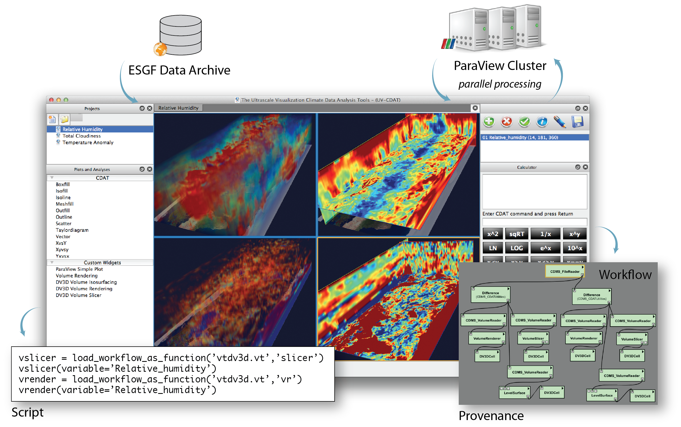

**Building the future of interactive analysis and visualization one component at a time.**

1 Kitware, Inc

2 Lawrence Berkeley National Laboratory (LBNL)

3 Lawrence Livermore National Laboratory (LLNL)

4 Los Alamos National Laboratory (LANL)

5 National Aeronautics and Space Administration (NASA) Goddard Space Flight Center (GSFC)

6 National Oceanic and Atmospheric Administration (NOAA)

7 Oak Ridge National Laboratory (ORNL)

8 Polytechnic Institute of New York University (NYU-Poly)

9 Tech-X Corporation

10 University of Utah

# Abstract

For the past three years, a large analysis and visualization effort—funded by the Department of Energy’s Office of Biological and Environmental Research (BER), the National Aeronautics and Space Administration (NASA), and the National Oceanic and Atmospheric Administration (NOAA)—has brought together a wide variety of industry-standard scientific computing libraries and applications for the benefit of the climate community. The architecture (or framework) we are talking about is known as the Ultra-scale Visualization Climate Data Analysis Tools (UV-CDAT), which serves the global climate simulation and observational research communities. To support interactive analysis and visualization, all components connect through a provenance application-programming interface to capture meaningful history and workflow. Components can be loosely coupled into the framework for fast integration or tightly coupled for greater system functionality and communication with other components. The overarching goal of UV-CDAT is to provide a framework for a new paradigm to access and analyze massive, distributed scientific data collections that leverages distributed architectures located throughout the world. This UV-CDAT framework addresses many challenges and opportunities in analysis and visualization, including parallelism for better efficiency, higher speed, and more accurate scientific inferences. Today, it currently provides more than 400 users access to more analysis and visualization products than any one source.

**Contents**

1 Abstract ii

2 Executive Summary 1

3 Overview 2

3.1 Problem Statement 2

3.2 Use Cases 3

3.3 Project Success and Accomplishments 5

3.3.1 Balanced Research and Development: Overall Architecture Design 5

3.3.2 Success of Software Integration 6

3.3.3 Simple Graphical User Interface (GUI) 7

3.3.4 Successful Use of DV3D 8

3.3.5 UV-CDAT Spatio-Temporal Parallel Pipeline using ParaView 9

3.3.6 ParCat 11

3.3.7 Distributed Arrays 12

3.3.8 VisIt 13

3.4 Milestones and Software Releases 14

3.5 Administration, Operations, and Plans for Maintenance 15

3.6 Help Desk and Weekly Traffic 15

3.7 Future Funding 16

4 Innovative Technology and Integration 17

4.1 Research & Development 17

4.1.1 Overview 17

4.1.2 Test-Driven Agile Software Processes 22

4.1.3 Secure Distributed Data Access 24

4.1.4 Product Services 24

4.1.5 Diagnostic Packages 25

4.1.6 Graphical User Interface 28

4.1.7 Scripting 29

4.1.8 Workflow and Provenance Generation 29

4.1.9 Parallel Processing and Analysis Infrastructure 29

4.1.10 Server-side Analysis and Visualization 31

4.1.11 Performance of Replication Client 31

4.1.12 Monitoring Services 31

5 Community Outreach 31

5.1 Workshops 31

5.2 Online Tutorials 32

5.3 Online Classes 32

5.4 Website Documentation 32

6 Collaborative Governance 32

7 The Future of UV-CDAT 34

8 References 36

Appendix A Enabling Technologies and Collaborations 37

Appendix B Outreach, Papers, Presentations, Poster, Reports, and 38

Animations 38

B.1 Outreach Activities 38

B.2 Papers 38

B.2.1 October 1, 2012 through September 30, 2013 38

B.2.2 October 1, 2011 through September 30, 2012 39

B.2.3 October 1, 2010 through September 30, 2011 40

B.3 Presentations 40

B.4 Posters 43

B.5 Reports 43

B.6 Animations 43

Appendix C Use Cases 44

Use-case 1: High spatial resolution, parallel, image sequence production 45

Use-case 2: High spatial resolution, parallel, time average 45

Use Case 3: Compute ensemble mean 46

Use case 4: Compute average multi-model ensemble mean 48

Use case 5: Compute departures from climatological boreal winter 48

Use case 6: Convert from hybrid to standard pressure levels 49

Use case 7: Compute a time series of a regional average 49

Use case 8: Computing a zonal mean 50

Use Case 9: Batch Processing 50

Use Case 10: Interactive Processing 50

Use Case 11: Time Dependent Processing 51

Use Case 12: Time Independent Processing 51

# Executive Summary

The mission of the Ultra-scale Visualization Climate Data Analysis Tools (UV-CDAT) is to provide the climate-research community with access to large-scale data, and analysis/visualization tools required for the modeling and observational climate communities. Its specific goals are to develop the software and workflow applications needed to (1) integrate U.S. Department of Energy’s (DOE’s) climate modeling and measurements archives; (2) develop infrastructure for national and international model/data comparisons; and (3) deploy a wide-range of climate data visualization, diagnostic, and analysis tools with familiar interfaces for very large, high-resolution climate data sets to meet the growing demands of this data rich community.

Funded under the DOE’s Office of Biological and Environmental Research (BER), in direct support of its climate science mission, the integrated, cross-institutional effort of computational and science teams consists of a consortium of four DOE national laboratories (Lawrence Berkeley [LBNL], Lawrence Livermore [LLNL], Los Alamos [LANL], and Oak Ridge [ORNL]); two universities (the Polytechnic Institute of New York University [NYU-Poly] and the University of Utah; the private company Kitware, Inc.; the private company Tech-X Corporation funded by the National Oceanic and Atmospheric Administration (NOAA); and the Goddard Space Flight Center (GSFC) funded by the National Aeronautics and Space Administration (NASA). Led by LLNL, the UV-CDAT team developed and delivered a production environment for data exploration and analysis of large-scale geospatial data. The production environment includes multiple national and international analysis and visualization products, such as the Climate Data Analysis Tools, VisTrails, ParaView, DV3D, VisIt, Earth System Modeling Framework (ESMF), and R. The resulting integrated enterprise is a powerful and complete front-end to a mixed set of visual-data exploration and analysis tools.

Working directly with climate science analysis projects, the consortium deployed computational resources useful to a wide variety of stakeholders, including scientists, policymakers, and the general public. Members of this consortium collaborate with other institutions and universities in researching data discovery, management, visualization, workflow analysis and provenance. In particular, we worked closely with scientific programs funded by DOE’s BER to advance the develop of state-of-the-art tools in support of BER’s science requirements, which includes making publicized data archives (such as model intercomparison projects [MIPs] data, observational data, and very high-resolution climate model simulations) more useful to stakeholders (i.e., climate researchers). In addition, we met specific needs of national and international climate projects by integrating and developing tools and techniques suitable for large data sets in a familiar, distributed, federated infrastructure. Finally, we provided international climate centers and U.S. government agencies with a wide-range of climate data analysis tools and diagnostic methods for ultra-large climate data sets—in particular, sequential and parallelized tools and methods needed to support working groups focused on model development and diagnosis.

To support both the user and developer communities, the core UV-CDAT team—composing of LLNL, ORNL, LANL, NYU-Poly, and Kitware—built upon the existing UV-CDAT website and utilize progressive open source documentation and proven tutorial tools (i.e., Sphinx, Docutils, MaxMind, YouTube, and others) to deliver a robust user and developer support system. The team also continues to leverage existing Kitware support tools used for UV-CDAT development, such as CMake, CTest, and CDash. In addition to support, the UV-CDAT team has focused on community outreach. In order to realize this goal, the UV-CDAT consortium provided summer and fall workshops, held online classes, published articles in leading journals and book chapters, and developed a governance document to facilitate community goodwill and collaboration.

We are submitting this final report at the end of our original project’s funding cycle. To continue to serve the climate-science community, we are currently seeking to integrate our work into the DOE Enterprise Earth System Modeling Project. Such participation would allow us to maintain and enhance UV-CDAT production and operation and continue to serve the climate-science community.

*At this time, the entire UV-CDAT team would like to take this opportunity to sincerely thank our funding agencies in the DOE BER Office—as well as our national and international collaborators, stakeholders, and partners—for allowing us to work with you and the climate-science community these past few years.*

# Overview

## Problem Statement

As stated in our original proposal, climate science has moved beyond the physical climate to include detailed carbon cycle hydrology, biogeochemical and other feedback processes within new Earth system models. As a result, a large number of new variables are required to track tracers in current and future Earth system models. In addition, observational programs and field campaigns are generating increasingly rich and more complex data sets. Advanced tools for managing, analyzing and visualizing ultra-scale climate data are required to maintain the rapid progress in our scientific understanding and prediction of climate change and its impacts across all scales and to apply this understanding to the decision-making process. With that, the Ultra-scale Visualization Climate Data Analysis Tools (UV-CDAT) was established to address the needs of modern-day climate data centers and climate researchers. Specifically, UV-CDAT addresses the needs of both data centers and researchers for in the area of analysis and visualization of large and complex data sets. Under the leadership of the DOE BER, the UV-CDAT team consists of four DOE national laboratories (Lawrence Berkeley [LBNL], Lawrence Livermore [LLNL], Los Alamos [LANL], and Oak Ridge [ORNL]); two universities (Polytechnic Institute of New York University [NYU-Poly] and the University of Utah; two private companies (Kitware, Inc. and Tech-X Corporation), National Oceanic and Atmospheric Administration (NOAA); and the National Aeronautics and Space Administration (NASA) Goddard Space Flight Center (GSFC). Although this development effort is primarily coordinated nationally, it is beginning to attract a broader base of international developers interested in extending UV-CDAT for their climate modeling efforts. UV-CDAT’s work has resulted in new ways of looking at data, empowering scientists to pull together disparate tools for unique climate-science undertakings. Through this UV-CDAT effort, the team was able to deliver the following proposal goals:

* An overall architecture for incorporating existing and future software components;
* Analysis and visualization of heterogeneous data sources (simulations, observations, and re-analysis)—data analysis that cuts across multiple disciplinary domains;
* Workflow and provenance for user reproducibility;
* Parallelism and “big data” analytics;
* New boundaries for diagnostics (such as: ensemble analysis, uncertainty quantification, and metrics) computation; and
* On-going support for climate/atmospheric model and data evaluation activities and projects, such as the Intergovernmental Panel on Climate Change (IPCC) assessment report, DOE’s Enterprise Earth System Modeling Project, NASA Center for Climate Simulation (NCCS), and NASA Global Modeling and Assimilation Office.

As a result of the substantial analysis and visualization requirements for the Earth System Modeling community, particularly at global and continental scales, we have built and deliver an advanced application (i.e., UV-CDAT) that can locally and remotely access ultra-scale globally federated data archives, provide high-performance parallel analysis and visualization capabilities to the desktop of a climate scientist, and integrated community proven tools to help scientists make informed decisions on climate change consequences. The UV-CDAT software stands out as an emerging collective of analysis and visualization products for the community, providing the integration of over 70 distinct packages and libraries, including over a dozen national participating developing sites, a growing number of users (over 400), speed up of analysis and visualization routines, and software sophistication to lead into the future.

UV-CDAT is built on the integration of software and hardware resources spread across DOE, NASA, and university data centers carrying out climate research. In greater detail, it builds on the following key software technologies: (1) the Climate Data Analysis Tools (CDAT) framework developed at LLNL for the analysis, visualization, and management of large-scale distributed climate data; (2) ParaView: an open source, multi-platform parallel capable visualization tool with recently added capabilities to better support specific needs of the climate science community; (3) VisTrails, an open-source scientific workflow and provenance management system to support data exploration and visualization; and (4) VisIt: an open source, parallel capable visual data exploration and analysis tool capable of running on a diverse set of platforms ranging from laptops to DOE's largest supercomputers. These combined tools, along with others (i.e., R), and custom packages (e.g. NASA’s DV3D and NOAA’s ESMF), form UV-CDAT and provide a synergistic approach to the scientific analyze and visualization of climate model and observational output. The member’s work across institutional boundaries to contribute to the development and integration of disparate software that facilitates climate research and to enable scientist is using these disparate technologies with little or no effort under one framework. Close group collaborations and marathon national face-to-face meetings, teleconferences, coding and debugging sessions met the requirements for such an ambitious endeavor. Group software development and milestones include the following:

* Interactive and batch analysis, diagnostics, and visualization development, including support for exploring new ways of interacting with comparative visualization and statistical analyses;
* Robust tools for regridding, reprojection, and aggregation, including support for unstructured grids and non-gridded climate data, and geospatial formats often used for observational data sets;
* Graphical User Interface design, for ease-of-use;
* Workflow analysis and provenance management;
* Parallel visualization and analysis tools (exploiting parallel input/output (I/O);
* Monitoring and metrics, for reporting data and system use, and
* Website and mailing lists, for helping users address questions and issues pertaining to the UV-CDAT system.

UV-CDAT’s success can be determined by its expanding use. It is now integrated with Earth System Grid Federation (ESGF) as a front-end access mechanism to acquire data for analysis and visualization and as a prototype back-end tool used to reduce data sets and return visualization products. It is also expanding its use to other DOE and NASA funded projects as the corner stone of emerging inter-agency proposed projects. In particular, two future funded projects under BER’s Earth System Modeling efforts aims to use UV-CDAT to deliver new capabilities that will further facilitate interactive and visual exploration and diagnostics of simulation and observational output. These projects have a joint vision for large-scale visualization and analysis of climate data and will work to organize and expand UV-CDAT’s capabilities.

## Use Cases

The UV-CDAT project was founded on a large set of use cases, which have significantly driven its development activities and prompted it to support both interactive and batch processing. For a climate scientist to be able to use the tool, interactive processing requires performance sufficient to keep the scientist engaged. We envision batch processing to involve submitting a job to a supercomputer much as a simulation is submitted. For interactive use cases, the team has assembled a front-end graphical user interface (GUI) for any number of possible scenarios and combinations there of. For batch processing, the time constraints for the interactive use case are obviated, but the requirement for scripting workflows becomes paramount. The typical UV-CDAT large-scale batch use case is one involving a large number of time steps that process a small spatial granularity. Independent temporal parallelism is embarrassingly parallel with respect to time, i.e., an individual time step is not dependent on any other time step to produce an analysis product such as a time-evolution video of sea surface height. Time-dependent use cases require other time steps for the production of such analysis products as a time averaging operation or ensemble analysis. This distinction becomes very important because it affects the chosen parallel architecture while maintaining performance.

UV-CDAT performs numerous parallel batch tasks that can generally be divided into the set of parallel use cases, some shown in Figure 1.



**Figure 1.** *Use case diagram for UV-CDAT*

These use cases are for tasks commonly performed by climate model analysts that require explicit spatial, temporal, spatio-temporal, and multi-attribute considerations. Most of these use cases have at least one embarrassingly parallel dimension. These are time (3,4,6,8), space (3,4,5,6,7), ensemble member (2,3,5,6,7,8), or model (1,2,3,5,6,7,8). Although many of these operations have embarrassingly parallel aspects, climate data in parallel often create a data-intensive problem with I/O scaling difficulties. Many of the parallel architectures developed for UV-CDAT account for this problem. The use cases that have drive UV-CDAT’s parallel development are:

* Use-case 1: High-res, parallel, image sequence
* Use-case 2: High-res, parallel, time average
* Use case 3: Compute ensemble mean
* Use case 4: Compute multi-model ensemble mean
* Use case 5: Compute departures from a climatological DJF
* Use case 6: Convert from hybrid to standard pressure levels
* Use case 7: Compute a time series
* Use case 8: Computing a zonal mean
* Use case 9: Batch processing
* Use case 10: Interactive processing
* Use case 11: Time-dependent processing
* Use case 12: Time-independent processing
* Use case 13: Data filtering

For more detailed information on use cases, see Appendix C and also visit the UV-CDAT use case website at: <http://uv-cdat.org/wiki/UseCases>.

## Project Success and Accomplishments

The ultimate goal of this project is to address the particular requirements and ultra-scale comparative capabilities needed for access, analytics, and visualization of climate data sets for BER and NASA projects. Many milestones have been archived and if funding persists, many more on the way. The UV-CDAT team delivered analysis and visualization products associated with these milestones, listed under section 3.1, to the research community. As appropriate, UV-CDAT targeted the following user groups:

* Scientist (working group I types);
* Impacts, adaptations (working group II types); and
* Mitigation (working group III types)

The impacts and mitigation working groups were primarily targeted by other funding agencies such as NASA, NOAA, universities, and private companies. BER efforts targeted scientists only.

Other DOE projects (e.g., the multiple BER climate modeling project initiatives and ESGF) rely on UV-CDAT to provide visualization, analysis, and diagnostics for the climate-science community. As scientists increasingly depend on more sophisticated, next-generation atmospheric–ocean–sea–ice–land models, they will have a greater need for analysis and visualization resources. Central to the current and future dissemination of data is the ESGF and central to serving up analysis and visualization products to ESGF is UV-CDAT. Although ESGF focuses primarily on data management, it allows analysis tools such as UV-CDAT to access its data holdings and produce server-side products.

### Balanced Research and Development: Overall Architecture Design



**Figure 2.** *The UV-CDAT architecture shows the framework components, either integrated tightly or loosely coupled. From this design, other packages can be joined seamlessly.*

UV-CDAT is a workflow-based, provenance-enabled system that integrates climate data analysis libraries and visualization tools in an end-to-end application. UV-CDAT lets users build complex data analysis and visualization workflows that use predefined components for data transformations, can collect data from disparate data sources outside ESGF, and allows for user-defined local and report processing steps. The design of UV-CDAT, shown in Figure 2, incorporates the following list of requirements:

* Interactive and batch operations;
* workflow analysis and provenance management;
* parallel visualization and analysis tools (exploiting parallel I/O);
* local and remote visualization and data access;
* comparative visualization and statistical analyses;
* robust tools for regridding, reprojection, and aggregation; and
* support for unstructured grids and non-gridded observational data, including geospatial formats often used for observational data sets.

To achieve this design, UV-CDAT uses several components, including CDAT, VisTrails, DV3D, ParaView, and VTK to provide high-performance parallel-streaming data analysis and visualization of massive climate data sets (see Figure 2). These core components are tightly coupled for greater system performance. In addition, UV-CDAT is a very flexible and extensible system. Using VisTrails' package mechanism, it’s straightforward to loosely integrate (or incorporate) other tools, including VisIt, ViSUS, R and MatLab for data analysis and visualization without modifications to the system core. This package mechanism enables developers to expose their libraries (written in any language) to the system by a thin Python interface through a set of VisTrails modules. Users are able to interact with the system in different ways, by using the UV-CDAT GUI, the VisTrails’ workflow builder or through Python scripts.

We believe that providing these different ways of integration and interaction, including a simple but powerful GUI reduces the barriers for adoption. In addition, relatively simple interfaces are needed for other target audiences (for example, adaptation and mitigation researchers and decision makers).

### Success of Software Integration

Nationally, the UV-CDAT software development team (and indeed the community) has accomplished something that has never been attempted or completed at this level of software engineering for the climate community, the integration of over 70 disparate software packages and libraries (listed in Table 1) for large-scale data analysis and visualization, as depicted in Figure 3.

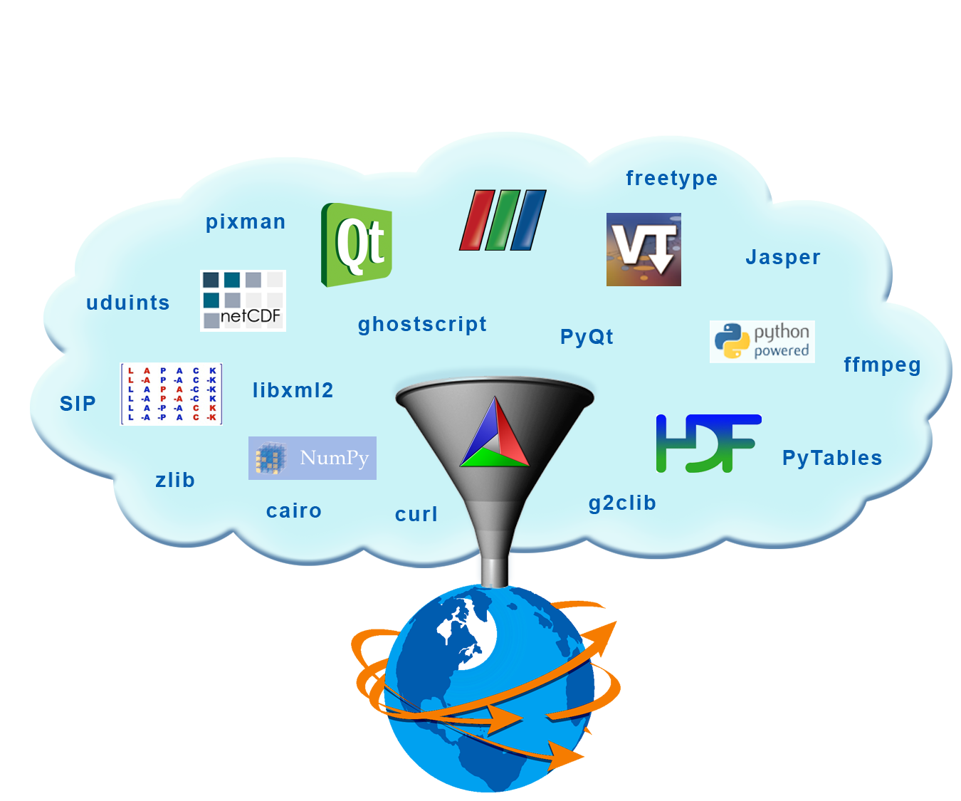

**Figure 3.** *Build knowledge of UV-CDAT has been transferred to the following groups: LLNL, Kitware, Tech-X, and LBNL*

UV-CDAT uses Git, an open source distributed version control system, to manage the UV-CDAT software repository. Git encourages branch workflows where each feature could be a separate branch. If there are multiple developers working on a single project, which is the case for UV-CDAT, it is essential to design a workflow to facilitate collaborative development and reduce software breakages. The UV-CDAT software development team has set up three maintenance branches: “master”, “next” and “release” in which “master” is the most reliable integration branch, “next” is the cutting edge integration branch and “release” is the latest release branch of UV-CDAT. This separation also allows the team to build and test each of these branches on dashboards to ensure software quality and reliability.

**Table 1.** *UV-CDAT builds over 70 external packages, listed below.*

|  |  |  |  |  |
| --- | --- | --- | --- | --- |
| **basemap 1.0.5** | **pkgconfig 0.23.0** | **termcap 1.3.1** | **readline 6.2** | **libxml2 2.7.8** |
| **libxslt 1.1.26** | **CURL 7.22.0** | **YASM 1.2.0** | **ffmpeg 0.11.1** | **zlib 1.2.5** |
| **png 1.5.1** | **CDAT 1.3.1** | **jpeg v8c** | **tiff 3.9.4** | **pbmplus** |
| **Tlc/Tk 8.5.9** | **LAPACK/CLAPACK** | **freetype 2.4.10** | **Pixman 0.30.0** | **fontconfig 2.10.1** |
| **Cairo 1.10.2** | **uuid 1.6.2** | **udunits2 2.1.24** | **shapely 1.2.14** | **HDF5 1.8.8** |
| **NetCDF 4.3.0** | **Qt 4.7.2** | **jasper 1.900.1** | **g2clib 1.2.5** | **Python 2.7.4** |
| **VisIt 2.6.0** | **SIP 4.14.6** | **PyQt 4.10.1** | **PyOpenGL** | **Numpy 1.7.1** |
| **Pmw 1.3.2** | **CMOR 2.8.3** | **Matplotlib 1.2.0** | **GEOS 3.3.5** | **Libcf 1.0-beta11** |
| **Cython 0.16** | **MPI 1.6.4** | **ESMF 6.1.0** | **setuptools 0.6c11** | **gui_support** |
| **distribute 0.6.45** | **Pip 1.3.1** | **MyProxyClient 1.3.0** | **Numexpr 2.1** | **Lepl 5.1.3** |
| **Sphinx 1.2.b1** | **pyzmq 13.1.0** | **spyder 2.2.0** | **tornado 3.1** | **IPYTHON 0.13** |
| **Mpi4py 1.3** | **NetCDFPLUS 4.2.1.1** | **R 2.15.1** | **ParaView 3.11.1** | **Pyspharm 1.0.7** |
| **PyTables 2.4.0** | **SCIPY 0.12.0** | **scikits 0.12** | **VTK 5.9.0** | **VisTrails** |
| **DV3D** | **CDATLogger** | **WGET 1.12** | **gdal 1.9.1** | **docutiles 0.10** |
| **jinja2 2.7** | **pyopenssl 0.13** | **pygments 1.6** | **blaze** | **llvm** |
| **llvmpy** | **Django 1.5.1** | **Numba 0.9** |  |  |

Kitware CMake is the build tool responsible for building software. Kitware CTest is a test driver tool, used to run regression tests and Kitware CDash is a web application for displaying testing results on dashboards and performing continuous integration testing. UV-CDAT primarily uses CMake and other Python scripts to build libraries and their dependencies on any given system. To ensure that UV-CDAT tools and applications build and perform as expected, it is essential that the tools be built and that regression tests are run when developers push new changes to the repository. The development team is working towards setting continuous (i.e., run when the repository server receives new changes) and nightly (i.e., runs every night at a predefined time) dashboards, which will build and test UV-CDAT against latest changes.

### Simple Graphical User Interface (GUI)

The UV-CDAT GUI, the main window for UV-CDAT, is shown in Figure 4. It is based on the notion of a spreadsheet (middle) or a resizable grid in which each cell contain one or more visual images. By using intuitive drag-and-drop operations, visualizations can be created, modified, copied, rearranged, and compared. Spreadsheets maintain their provenance and can be saved and reloaded. These visualizations can be used for data exploration and decision-making, while at the same time being completely customizable and reproducible.

Around the spreadsheet are the tools for building visualizations, as shown in Figure 4. The project view (top left) allows one to group spreadsheets into projects and to name visualizations and spreadsheets. The plot view (bottom left) allows for the use and customization of available plot types. The variable view (top right) allows data variables to be edited. The bottom right contains a variable editor widget, making editing a variable similar to using a pocket calculator. Using the UV-CDAT GUI, creating a visualization can be as simple as dragging a variable to a spreadsheet cell and then dragging a plot type to the same cell.

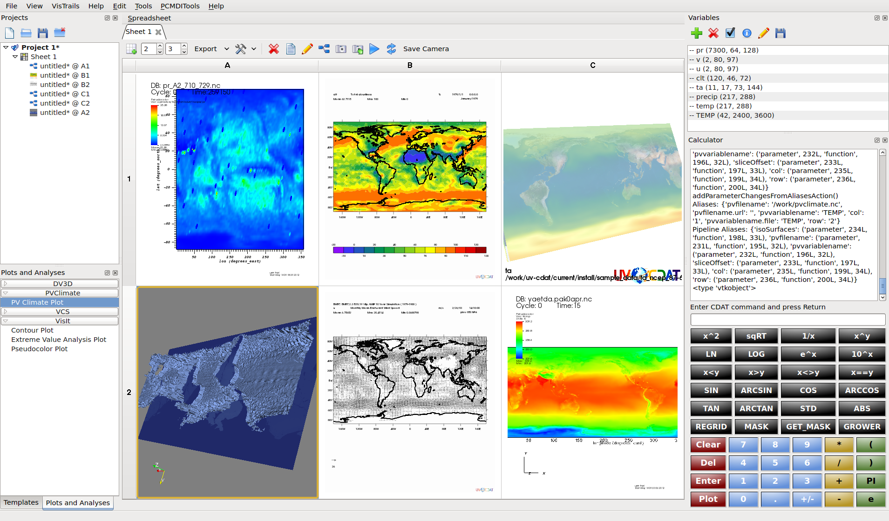

**Figure 4.** *Extreme value analysis plotting using an array of visualization tools, such as: VisIt-R (upper left), ParaView plot (lower left), CDAT plot (middle), DV3D (upper right), and VisIt (lower right).*

### Successful Use of DV3D

Using the three dimensional DV3D tools in UV-CDAT, we have explored model and observational data in ways that previously would have been difficult if not impossible using traditional visualization tools. Described are two of many important use cases that show the success of DV3D:

1. *Case 1 meridional (V) wind anomalies at 200hPa.* Using the Hovmöller slicer on the MERRA reanalysis, an interesting pattern emerged in the mid latitude 200hPa V wind anomaly. We have not yet identified the source of this apparent wave that appears to have a period of about 5 years and it may be a feature of the input data to reanalysis. The pattern seems to appear after 1995 and may be associated with stationary Rossby waves. We are still investigating this phenomenon and although it may be an artifact of data assimilation, it may prove to be important.
2. *Case 2 details of jet stream location from AMWG diagnostics.* The AMWG diagnostic package generates nearly 800 plots for one experiment. The plots are displayed in 2 dimensions (e.g. latitude-height) but it is impossible to see any zonal regional differences. By invoking UV-CDAT/DV3D, it is possible to examine in detail the regional differences that occur in the zonal (U) wind component revealing subtle difference in the zonal winds and shifts in the pole-ward movement of the mid-latitude jet stream.

In order to facilitate use case exploratory processes, the NASA Center for Climate Simulation has deployed UV-CDAT within a distributed parallel visualization framework, thereby enabling simultaneous interactive visualization of the scores of variables involved in many model diagnostic and intercomparison tasks. This framework employs a hyperwall cluster that currently consists of a 5x3 array of 46-inch touchscreen displays, each with a dedicated compute (client) node, plus a single control (server) node (Figure 5). In this framework, an instance of UV-CDAT runs on each node, coordinated using socket connections between the client nodes and the server node. Each client instance opens a single cell visualization spreadsheet window, covering its hyperwall display. The user interacts with the GUI of the server instance using one of the touchscreen displays. In a typical use case scenario, the user opens (or constructs) a workflow with 15 cell modules on the server node. At execution time, the server instance sends edited versions of the workflow to each client node for local execution. Each client workflow consists of one of the cell modules (and all its upstream modules) from the server workflow.

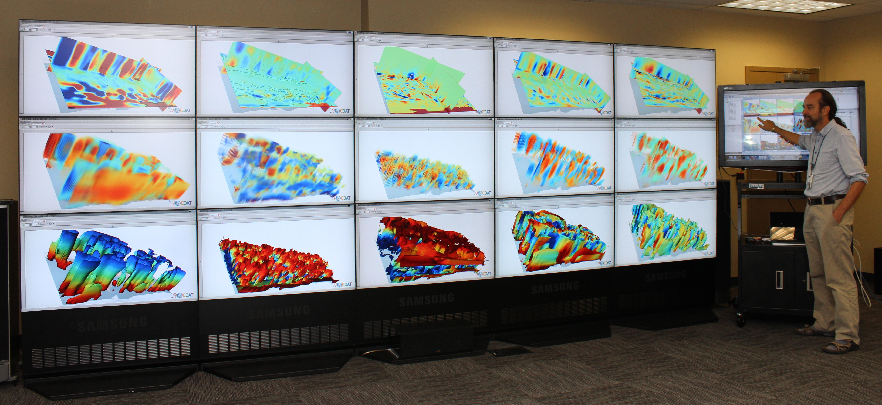

**Figure 5.** *The UV-CDAT distributed visualization framework deployed on the NASA NCCS hyperwall. UVCDAT team member, Tom Maxwell, uses the touch screen to demonstrate the interactive procedure. This configuration enables scientists to exploit the full capacity of the hyperwall cluster (32 dual-core Xeon Harpertown processors, 16 Quadro FX 1700 GPUs, and a 17- by 6-foot, 15.7-million pixel display) in support of interactive visual data analysis and understanding of very complex climate data sets.*

### UV-CDAT Spatio-Temporal Parallel Pipeline using ParaView

Many climate data sets have, in addition to a high spatial resolution, a high temporal resolution. In many instances, simulations output daily or monthly averages, with data sets possibly covering a total timespan of decades.  Due to this high temporal resolution, there is a critical need to have a fast, scalable method for processing a large number of timesteps. In response, the UV-CDAT spatio-temporal pipeline was devised to solve UV-CDAT Use Case 1 and Use Case 2.

***Use Case 1:***Use Case 1 involves a data set with high spatial and temporal resolution. The task is to produce an image sequence of the data set by producing one image per timestep. One key aspect here is that there are no dependencies between timesteps, and each timestep can be processed independently.

In a fully data-parallel model, all available processors would take part in reading the first timestep, perform any required analysis, and then take part in producing the final image output. Then all processors would load the second timestep, and the cycle repeats until all timesteps have been processed. In this case, timesteps are accessed sequentially, and only spatial parallelism is utilized.



**Figure 6.** *Spatio-temporal pipeline: Use Case 1 - High spatial resolution, high temporal resolution, image sequence production*

In a fully data-parallel model, all available processors would take part in reading the first timestep, perform any required analysis, and then take part in producing the final image output. Then all processors would load the second timestep, and the cycle repeats until all timesteps have been processed. In this case, timesteps are accessed sequentially, and only spatial parallelism is utilized.

In the UV-CDAT spatio-temporal pipeline, parallelism is extended both spatially and temporally. This means that multiple timesteps can be processed simultaneously. This is permissible since each timestep can be processed independently of each other. In order to achieve temporal parallelism, the available processors are divided into groups called time compartments. The number of total time compartments is dependent on the number of processes and the size of a time compartment, which is constant over all time compartments. Each time compartment can now load and process a timestep independently of each other, resulting in multiple timesteps being worked on simultaneously. Figure 6 illustrates how processors are broken up into time compartments, and how work is distributed among them. When there are more timesteps than time compartments, the files are assigned in round-robin fashion to time compartments, so it is possible for a time compartment to process multiple timesteps. Within a time compartment, its’ assigned timesteps are processed one at a time.

The amount of temporal parallelism versus spatial parallelism is controlled by the size of one time compartment, which is a user configurable parameter. When the time compartment size is large, there are fewer total time compartments, which results in less temporal parallelism and more spatial parallelism. On the other hand, if the time compartment size is small, there are then more time compartments, and the amount of temporal parallelism is higher, the amount of spatial parallelism decreases.

***Use Case 2:***Similar to Use Case 1, Use Case 2 also involves analyzing climate data, which has both high spatial and temporal resolution. The difference with Use Case 1 is that instead of having each timestep be processed independently, some type of reduction operation among several timesteps must be performed, with the output being various statistics. One example would be calculating yearly averages from monthly data. In this case, every 12 timesteps comprising of one year must be averaged together. Supported reduction operations include average, min, max, and standard deviation.

The UV-CDAT spatio-temporal pipeline can also be used to support Use Case 2, as illustrated by Figure 7. Each time compartment loads one-or-more timesteps like before, but with an additional reduction step, which combines the results of several time compartments into a single data product.



**Figure 7.** *Spatio-temporal pipeline: Use Case 2  - High spatial resolution, high temporal resolution, time average*

Initial results from the UV-CDAT spatio-temporal pipeline’s performance show vast performance gains. In Use Case 1, there was an improvement from hours to minutes when switching to the spatio-temporal pipeline. Use Case 2 also showed an order of magnitude improvement when using the spatio-temporal pipeline. Similar results have been shown over multiple supercomputers and multiple file systems.

### ParCat

Much of the post processing and analysis work involved in studying climate data sets requires fast statistical methods—calculating averages and histograms, and finding minimums/maximums over a data set. Additionally, multi-model comparison runs require the difference of two data sets, or finding an average-of-differences. These functions accelerate use cases 3, 4, and 8 identified in section 3.2.

The ParaView parallelism discussed previously works well for analysis of data sets with high spatial resolution. Developed specifically for UV-CDAT, ParCAT can improve time-to-solution for analysis of data sets with high temporal resolution or number of timesteps but with lower spatial resolution. ParCAT can provide averages, differences or sums of two data sets, histograms, and the average-of-differences of two data sets, and can find the minimum and maximum values for a data set. Many of these statistical operations are embarrassingly parallel in multiple dimensions. For example, calculating a spatio-temporal average map is parallelizable in time, space, and per variable. Some variables even allow for a fourth parallelizable dimension—height or depth. However, because these data sets comprise hundreds of files, consuming hundreds of gigabytes of storage, the amount of I/O (relative to compute time) is a critical factor for achieving good parallel speedups.

ParCAT reads standard netCDF files and produces netCDF output and uses the parallel netCDF libraries to read and write the files in parallel. ParCAT is also a command-line utility that can be built on a wide variety of platforms. This makes it easy to embed ParCAT in other analysis tools such as UV-CDAT or in scripts.

A front-end GUI was developed for ParCAT so parallel (pre-)processing of large data sets can be done directly from within UV-CDAT. The user selects which data sets are of interest and what processing needs doing, then the job is submitted and the results are returned to UV-CDAT.

Because most processors or nodes utilize multiple compute cores for processing, ParCAT was designed to use both multiple cores on a node and multiple nodes to maximize I/O efficiency. Each node opens one or more files and then each core on the node processes data. In this way, there is less I/O contention and ParCAT should scale to at least one node per file in the data set.

Figure 8 shows results of processing a data set using a small partition on Titan. There are 349 variables with ½-degree spatial resolution and 20 years of monthly timesteps (240 files total). ParCAT processes multiple variables in parallel across cores and reads multiple files per node. With a larger data set and more nodes, the speedup from one process should be even better.

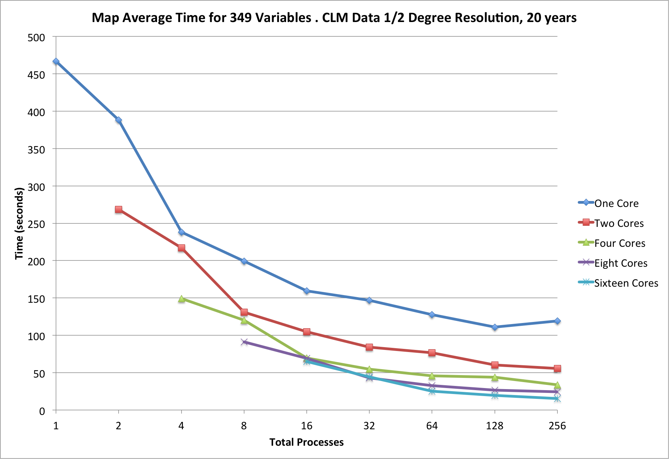

**Figure 8.** *Using ParCAT on Jaguar. Calculating temporal average of 20 years of monthly data with 349 variables*

### Distributed Arrays

Use cases 2-8 can benefit from utilizing distributed arrays in the same way as ParCAT by leveraging multiple processing units to perform similar postprocessing tasks on different sets of data, faster and with a smaller memory footprint per processor. However, distributed arrays can also be applied to cases where each processor (or core) must communicate with other processors, not only with a master processor. Data filtering operations (use case 13), including smoothing and feature extraction, fall in this category.

Limits to parallel scalability of distributed arrays are those of ParCAT: the ratio of serial to parallel section (not all operations can be parallelized) and load balancing (which can cause some processors to wait for other processors). Both of these effects cause the parallel speedup, i.e. the ratio single processor wall clock time to parallel processor execution time, to plateau beyond a certain number of processors. For distributed arrays, there is in addition the communication cost, which itself involves latency and throughput, and which increases with higher numbers of processors. As a result, the execution speed always decreases beyond a certain number of processors when there is intra-processor communication. To reduce the communication cost, the partitioning of the data should always attempt to minimize the ratio of surface (proportional to communication) over volume (proportional to the work load).

UV-CDAT implements a very flexible distributed array representation based on MPI-2 one-sided communication. As with other distributed array implementations, each processor holds a subset of the data. However, in contrast to other implementations, subsets of the local data can be exported to any other processor, not only to a neighboring processor. Moreover, UV-CDAT supports distributed arrays in any number of dimensions for all the common data types (float, double, and integer). This was achieved by breaking the local data array into sub-boxes, with each sub-box uniquely defined by a set of integer indices, regardless of the dimensionality of the array.

A particular challenge was to integrate the distributed array capability into software that was originally designed to operate serially. Because there is a large body of legacy CDAT scripts, the new distributed array extensions were required to operate seamlessly with older scripts. We opted for a minimalistic approach, adding a very small set of methods to the Climate Data Management System (CDMS) array object, which is essentially a standard Numpy array object with additional metadata and methods attached. The new distributed arrays methods in CDMS are:

* exposeHalo(ghostWidth)
* fetchHaloData(procNumber, windowId)

Here, ghostWidth refers to the number of ghost values (the same in all directions), procNumber the processor rank, and windowId the unique sub-box identifier for each data window (e.g., the tuple [-1,0] would denote the west side of the array). The Python implementation uses the Mpi4Py module to exchange data among processors. Despite its simplicity, this application-programming interface supports discretization filters of any order. Figure 9 shows the scaling obtained by applying a two-dimensional finite difference Laplace operator discretization on a 128-core cluster to extract features (the Laplacian is highest where the data have sharp gradients). The size of the local data (2000x2000) was kept constant as the number of processors increased (weak scaling). The communication cost increases and amounts to 15% for 128 processors. Therefore, a 128-times larger problem can be solved using only 15% more wall clock time.

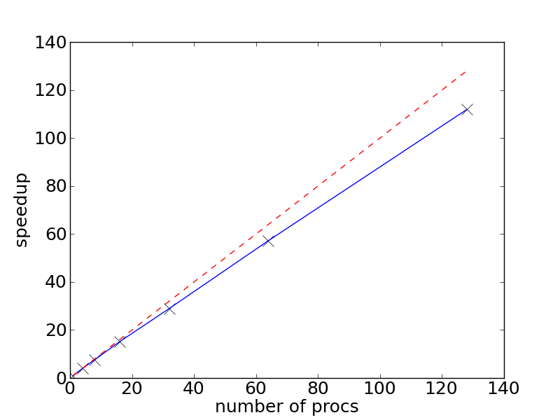

**Figure 9.** *Weak scaling of UV-CDAT’s distributed arrays applied to a two-dimensional Laplace filter post-processing test case. The red dashed line represents the ideal scaling. The blue solid line represents the actual speedup obtained on a 128-core cluster with Infiniband interconnect.*

### VisIt

VisIt’s server infrastructure provides parallelism in three significant categories: databases, plots, and operations. These three components are individually optimized to take advantage of scaling and communication requirements with respect to underlying algorithms. Databases provide the ability to read massive data sets in parallel, where operations can manipulate the data on a per-process basis and finally visualize the plot using a scalable rendering functionality. VisIt’s integration into UV-CDAT enables climate science users to exercise several spatio-temporal parallel processing algorithms described in the rest of the section.

Parallel databases are aware of the underlying representation on the disk and can take advantage of domain decomposition and parallel I/O operations when needed for analysis and visualization plots. In addition VisIt’s operations are aware of the decomposition and are able to operate over the data utilizing communication to solve the task at hand. In addition, all plots within VisIt support parallel rendering in scalable rendering mode to handle visualization needs even for the largest data sets.

New parallel analysis frameworks have been added to VisIt, including extensions to the current set of operators. Generalized Extreme Value Analysis and Peaks Over-Threshold are two common operators exercised frequently by the climate science community. Figure 10 portrays both operators processing over 20 years worth of information and correlating two separate ensemble runs. We exercise several custom R analysis routines within VisIt to provide a robust solution to the climate community. Both operators exercise spatio‑temporal parallelism.



**Figure 10.** *20-year annual return values for daily precipitation CAM5.1, 1979-2005, ensemble of 2 runs. Peaks-Over-Threshold (left) and Generalized Extreme Value Analysis (right).*

Although the addition of optimized VisIt operations provides a new range of capabilities to our users, scientists still requested modifications greater than the parameter space allowed by the algorithms. Users also wanted to exercise familiar functionality such as from the CDAT toolset. Our solution, and the second parallel analysis extension, was to add a general scripting operator within VisIt to facilitate creating custom analysis routines in addition to pre-existing operations. The new scripting framework in VisIt supports Python & R. We also provided helper functions to hide complex requirements for communicating in a distributed environment, as well as a mechanism to import the core CDAT API into VisIt, thereby allowing users to exercise climate-centric functionality in an embarrassingly parallel way. Furthermore, we included MPI support in Python & R to create communication among custom scripts written by the user community.

Figure 11 shows VisIt’s ability to easily create variants of analysis operations with very simple changes. Several core features of the parallel analysis framework include template function support, inclusion of familiar climate toolchains such as CDAT, and access to parallel libraries such as Mpi4Py in Python & pbdMPI in R.



**Figure 11.** Ability to extend VisIt to perform dynamic and complex operations in VisIt using Python & R.

The third analysis addition to VisIt included a new set of tools to enable parallel climate science analysis. The stand-alone deliverable provides analysis routines that characterize tropical cyclones across models (CAM5), resolutions (2,1,1/4,1/8 degrees), and forcings (climo, SST+2, 2xCO2). The code-base also evaluates precipitation and cyclogenesis. In addition, our team provided algorithms for detecting extra-tropical cyclones and atmospheric rivers, and extreme precipitation structure. These algorithms are wrapped within a common infrastructure called TECA (Parallel Toolkit for Extreme Climate Analysis) that written with MPI support.

## Milestones and Software Releases

**Table 2.** *Table showing the UV-CDAT software release over the past years.*

|  |  |  |  |
| --- | --- | --- | --- |
| Product | Release Date | End of Engineering | End of Life/  End of Support |
| UV-CDAT 2.0.0 | Coming soon… | Open | Current |
| UV-CDAT 1.4.0 | August 5, 2013 | January 4, 2013 | January 4, 2013 |
| UV-CDAT 1.3.0 | April 29, 2013 | August 5, 2013 | August 5, 2013 |
| UV-CDAT 1.2.0 | January 6, 2013 | August 5, 2013 | August 5, 2013 |
| UV-CDAT 1.1.0 | June 29, 2012 | April 29, 2013 | April 29, 2013 |
| UV-CDAT 1.0.0 | May 9, 2012 | January 6, 2013 | January 6, 2013 |
| UV-CDAT Beta | April 4, 2012 | June 29, 2013 | June 29, 2013 |
| UV-CDAT Alpha | February 2, 2012 | May 9, 2012 | May 9, 2012 |

## Administration, Operations, and Plans for Maintenance

UV-CDAT management is critically important for the future service of high profile (and other equally important, if lower profile) analysis and visualization of large-scale data sets. As shown above, the UV-CDAT management consists of distinct parts but functions as a cohesive entity, with the workload distributed evenly among the working partners. From our experience with disparate development and as a collective, we know that future UV-CDAT management must address five distinct functions: operations, maintenance, engineering, training, and administration. These are the common building blocks for any large software effort. The needed work is to sustain the management of existing UV-CDAT tools, algorithms, and components used to analysis and visualize large climate data sets. These distinct functions are described in greater detail:

* **Operations** to ensure effective implementation and control of UV-CDAT operation activities. This work includes the status and monitoring of hardware, network, and software systems to ensure secure and reliable processing operations and data analysis, visualization, and diagnostics.
* **Maintenance** to ensure effective implementation and control of software, hardware and network activities to provide optimum performance levels needed by the community.
* **Engineering**to ensure effective implementation and control of technical support. This work entails proper design review, required development to conform to new standards and technologies, and documentation of changes for others to follow.
* **Training**to ensure effective implementation and control of training activities and user support. This work includes the training necessary for new projects, data providers and the diverse user community. It also includes: the UV-CDAT help desk; Frequently Asked Questions (FAQ); software-use tutorials (e.g., the UV-CDAT Tutorial: http://uv-cdat.org/tutorials/); support mailing lists (such as the uvcdat-support mailing list); and websites and wiki sites (such as the uv-cdat.org site). See section 3.8 for the help desk summary.
* **Administration** to ensure the establishment of policies and the planning and control of activities. This work is especially necessary for the overall operations, monitoring, and direction of the UV-CDAT performance and interfacing with stakeholders, program sponsors, team members, data centers, and programs.

For all these distinct functions, operator knowledge and performance will help to support a reliable UV-CDAT framework.

UV-CDAT will never be a static system. As the platforms on which it operates—server hardware, networks, operating systems, and browsers—evolve, UV-CDAT software must be adapted. UV-CDAT is also a collaborative development with components from several quasi-independent projects. As one component advances, adaptations in others will be required to support the updated functionality.

## Help Desk and Weekly Traffic

Our partners and the UV-CDAT team established a community help desk to assist users with information and resources and to help troubleshoot problems with analyzing and visualizing data, the UV-CDAT ecosystem, and products. This help desk service is provided in the form of software, website, and e-mail. Traffic on the UV-CDAT supported project help desk is increasing significantly as the project increases in recognition and in use. Figure 12 shows the new Askbot website for user ask questions and create help tickets. UV-CDAT team members are essential to keeping this operation going. We anticipate a lot of traffic considering user responses back and forth with help desk providers and follow-on questions by other users. Scientists in DOE, and NASA are charged with addressing science questions, while technical staffs at these institutions are charged with addressing UV-CDAT framework questions. These personnel spend a portion of their day scanning the list of new questions, divvying up the workload and responding to users. Questions that are resolved are place on the UV-CDAT FAQ list to circumvent answering repeat questions. We are moving away from the esg-support mailing list to the Askbot help desk for greater control and better tracking of questions. To do this, we are redirecting users from uv-cdat-support mailing list to the help desk.



**Figure 12.** *Summary of tickets created and closed since April 2011*

## Future Funding

Our project was designed as a next-generation open source tool for visualization and analysis of climate data that scales from small data sets on personal workstations through extreme-scale data residing on the supercomputers, as envisioned in DOE Enterprise Earth System Modeling Project (EESM). From the DOE perspective, our efforts will alien closely with EESM to provide provenance and workflow functionality, diagnostics, and provide high-performance parallel analysis and visualization capabilities to the desktop of scientists who will apply these tools to make informed decisions on meeting the energy needs of the nation. In addition, the team of developers will continue to collaborate with national and international government agencies, universities, and corporations to extend parallel software capabilities to meet the challenging needs of ultra-scale multi-model climate simulation and observation data archives.

# Innovative Technology and Integration

## Research & Development

### Overview

#### Software Practices

The UV-CDAT internal software practice is a rigorous process lending to robust testing and prototype use of new and established software libraries and packages before releasing into the overall framework. Practical and technological experience with proven technologies of large community applications by the team, over the course of many years, allows for careful integration and the build up of a completely new analytic software stack. For robustness, reliance on standards for data access, integration, processing and visualization is key, as the standards constitute the basis for interoperability with other systems, clients, and server-side processes. UV-CDAT has followed the right software practices from the beginning; by allowing a flexible architecture design to accommodate loosely coupled (i.e., fast) integration or tightly coupled (i.e., greater component interoperability) integration. This design has allowed the adoption of disparate application engines such as VisIt, ParaView, DV3D, Numpy, CDMS, and R while conforming to community standards such as NetCDF, HDF, CF, and many others.

Over the short lifespan of the UV-CDAT project, the complexity of the software has changed significantly. As mentioned in the first part of this report, all software components used must be directly relevant to the overall aim of UV-CDAT and the design and implementation of the software at all levels, must comply with a useful programming practice technique all the way up to the large scale software system. As the project’s name suggests, the focus is on practice and experience with software for ultra-scale climate analysis and visualization tools. The UV-CDAT project covered and put into practice as much of the software engineering techniques as physically possible.

The key criterion for submitting robust software to the UV-CDAT software stack is the design, implementation and the all important team testing. No exceptions are made. Contributions to the software stack must follow the rigorous software process practice before integration and release is made. Software processing steps include:

* Provide detailed design of software component sub-system and the niche that it will serve in the overall framework. Although there are many redundancies in the framework, this will help to priorities the work and help avoid system overlap;
* Present design and on programming implementation to the group during teleconferences and face-to-face meetings;
* Document sub-component (i.e., library or package) and tools that aid in solving software construction problems;
* Explain methods/techniques that cope with the special demands of the software component.

[Need more relevant text from Aashish.]

#### Climate Data

As a critical part of climate research, climate data files are defined in two parts: resulting simulation runs and observational information (i.e., raw data); and information describing the raw data, what is to be done with it, and how to use it (i.e., metadata). Formats on how to store and retrieve multidimensional data and describing metadata are many. In the climate modeling community, the many types of formats include the network Common Data Form (netCDF) [UCAR, 2008], the Hierarchical Data Format (HDF) [WMO, 2009], the GRIdded Binary (GRIB) [HDF Group, 2009], and the Post Processing (PP) format [PP, 2013]—to name only a few. However, over the recent years many groups running climate model simulation codes are opting to store their data in the netCDF format. NetCDF has evolved over time and has merged efforts with HDF for wider use in the creation, access, and sharing of geoscience (i.e., simulation and observational) data. That is, the netCDF API now sits on top of the HDF software stack as release version 4.x and takes full advantage of advanced HDF5 features such as grouping, compression, and chunking. For community archives, such as those held in the ESGF distributed federation data enterprise system, data are mainly stored in the netCDF format.

Along with storing data formats such as netCDF, the climate modeling and observational communities has selected a de facto methodology standard for defining the metadata that provides a definitive description of what the data in each variable represents, and the spatial and temporal properties of the data. Combined with the netCDF API, the Climate and Forecast (CF) [CF, 2009] metadata convention by definition enables users of data from different sources to decide which quantities are comparable, and facilitates building applications (such as UV-CDAT) with powerful extraction, regridding, and display capabilities. This metadata convention makes it possible for other geo-referencing data such as atmospheric, ocean, atmospheric chemistry, biogeochemistry, satellite observations, and others to be compared and displayed together with little or no effort on the part of scientists.

To ensure climate modeling and data centers can easily produce the netCDF CF metadata convention output, LLNL has developed the Climate Model Output Rewriter (CMOR) (CMOR, 2009). The structure of the files created by CMOR and the metadata they contain fulfill the requirements of many of the climate community's standard model experiments [Taylor, 2011]. A newer version of CMOR was developed for CMIP5 model assessments. These features include new grid storage capabilities and additional CF functionalities for observational and multi-model comparisons. As a component of UV-CDAT, CMOR has a built-in checker to make sure the model output complies with the netCDF CF conventions. This checker guarantees the quality of the output of the model data before it is archived into the ESGF CMIP5 distributed data repository.

Implemented as part of UV-CDAT, the Climate Data Management System (CDMS) [Drach, 2007] is used to automatically locate and extract metadata (i.e., variables, dimensions, grids, etc.) from the multi-model collection of model runs and analysis files. CDMS is defined as an object-oriented data management system, specialized for organizing multidimensional, gridded data used in climate analysis and simulation. As a fully CF compliant data-access tool, UV-CDAT (via CDMS) allows users to seamlessly read data from multiple sources for intercomparison multi-model, observational, and reanalysis studies. In addition to reading in netCDF CF compliant data, UV-CDAT can also write data in this format and convention. Besides netCDF, UV-CDAT can also read in HDF, GRIB, PP, binary, and other popular climate data file formats.

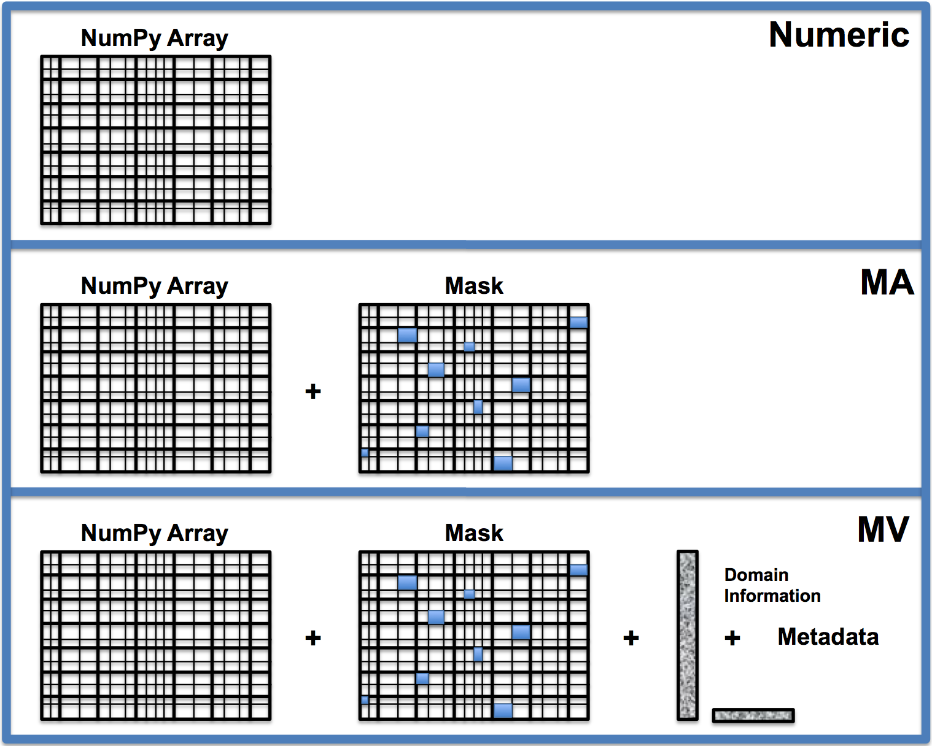

Figure XX: UV-CDAT supports the combination of many types of array objects such as: the Python Numpy Array, where all elements in the multidimensional array have the same data type (real, integer, etc.); the Masked Array (MA), a Numpy array with an optional missing data mask; and the Masked Variable (MV) (or Transient Variable), a MA with domain and metadata.

UV-CDAT expedites the manipulation of data arrays with missing values, an often-troublesome issue in geophysical applications. This problem is resolved by extending the Numerical Python (‘Numpy’) masked-array (MA) function to a masked-variable (MV) construct that retains information on the metadata attributes of data arrays. It also allows an extensive collection of Numpy mathematical operations to be executed. (See Figure XX.)

#### Analysis

Exploratory visualization is an important aid in the analysis process of climate scientists. Using UV-CDAT, they can perform different types of analyses: i) intra-model comparison by focusing on different variables from the same model, ii) inter-model comparison by focusing on the same variable from multiple models, and iii) verification and validation against observational data.

While UV-CDAT provides a drag-and-drop interface, making it convenient for climate scientists to create and customize visualizations, there is some scope for improving the quality of the visualizations to better cater to the analytical needs of the scientists. Concise visual representation provides a transparent window to the data, interacting with which the scientists can derive new insights about simulations, model input and output, model structure, etc. On the other hand, erroneous visualization design or high complexity of visual representations can impede the analysis process by causing expensive visual search for patterns.

Our goal is to eliminate the probability of such erroneous designs as much as possible within the visualization framework of UV-CDAT. To meet this goal, currently we are currently conducting an exploratory study of climate data visualizations conducted in tight collaboration with a pool of climate scientists. The study analyzes a large set of static climate data visualizations for identifying and categorizing their potential shortcomings in terms of visualization design. The ultimate outcome from this study will be a set of best practices for visualization design that will be integrated within UV-CDAT. These best practices can serve as model visualizations for specific analysis scenarios, and can thereby guide climate scientists in making informed choices about matching their intended tasks with the visual representations of the data.

#### Visualizations

UV-CDAT provides support for different visualizations for the different, aforementioned analysis scenarios. By integrating both scientific visualization methods like volume rendering, with information visualization techniques of using coordinated multiple views; UV-CDAT helps capture salient patterns in the data from different perspectives.

Visualizing the spatial correlation and variance is one of the main tasks in climate data analysis. Using the different 3D volume visualizations and geographical maps, scientists can accomplish this task. The different spatial aggregation methods by application of region masks are integrated within UV-CDAT, and those can be applied directly on the selected visualization types.

Another important task is to detect temporal trends and anomalies. This is supported within UV-CDAT in two ways: encoding time along the third dimension, where temporal patterns are represented by color maps and through coordination and linking between maps and line charts. By slicing through the maps and linking the different spatial positions to time-series in line charts, scientists can observe the temporal behavior of variables at those locations**.**

One of the analysis tasks that are underrepresented with the visualization framework of UV-CDAT is the task of analyzing multidimensional data. This is important, as at different spatial locations, scientists want to compare the behavior of multiple output variables, or the components of multidimensional output variables like Gross Primary Productivity (GPP).

We are currently working on adding visualizations that support multidimensional analysis within UV-CDAT, like parallel coordinates, heat maps, etc.

#### Graphical User Interface

UV-CDAT has been designed to enable exploration of climate data through an easy to use drag-and-drop interface.

Users can explore data variables through different plot types and create interactive visualizations. A grid in the form of a spreadsheet can show multiple visualizations, which enables visualizations to be compared and synched. Additionally, the various toolbars and panels can be detached, rearranged, and/or hidden to create a custom workspace suited to each user's taste.

#### Scripting

Scientists will always have pressing needs to write programs to ingest, manipulate, and display data and repeat these very same tasks as new data becomes available. Therefore the task at hand is to minimize this effort as much as possible so that scientists can focus on research. To this end, UV-CDAT makes use of an open-source, object-oriented, easy-to-learn scripting language (Python) to link together disparate software subsystems and packages to form an integrated environment for climate data analysis. The resulting software environment is user-friendly, reusable, portable, and promotes the sharing of common standards within the community. In this environment, specialized data access, diagnostic algorithms, and display software cooperate under a variety of user interfaces including command line, standalone application scripts, graphical user interfaces, and web browsers.

Besides being able to enter interactive command line calls at the Python prompt, users can produce a complete Python script (or series of commands) and save it to a file. This script can be executed at anytime, reopened and modified, and/or shared with colleagues. Scripts save the user from doing repetitive actives by describing exactly which commands to execute and in what sequence, so that the operations on the data are doing the right thing and in the correct sequence. Python is widely used in other scientific application areas and there are many books, tutorials, and websites on this popular fourth generation language.

#### Workflow and Provenance Control

***Workflow:*** Workflow systems provide well-defined languages for differentiating complex tasks from simpler ones. They also capture complex processes at various levels of detail and systematically record the provenance information necessary for automation, reproducibility, and sharing of results.

Scientific workflows are often used to perform data-intensive tasks and are represented as dataflow networks where the execution order is determined by the flow of data through the workflow. Scientific workflow systems offer a number of advantages over programs and scripts for constructing and managing computational tasks. In addition to providing a simple programming model, many systems provide intuitive visual programming interfaces, which make them more usable for users who do not have substantial programming expertise. The structure in workflow definitions also enables a series of operations and queries that simplify the manipulation and re-use of workflows. From now on in this document, we will use the terms scientific workflow, workflow, pipeline, and dataflow interchangeably.

Formally, a workflow specification is defined by sets of modules, input ports, output ports, connections, and a function that assigns a unique module to input and output ports. Additionally each port (input or output) has an associated type and a name that is unique across the ports of the same module. A module signature is defined as a set of pairs, where each pair contains a port name and its type. In addition, each module has a set of parameters. Each parameter has unique name across the set of parameters of the same module.

A workflow instance is a specification combined with bindings that provide values to parameters in the modules. A workflow run is the execution of a pipeline in the order determined by the network of modules and connections.

***Data provenance:*** In the context of scientific workflows, data provenance is a record of the derivation of a set of results. There are two distinct forms of provenance: prospective and retrospective. Prospective provenance captures the specification of a computational task (i.e., a workflow specification or instance); it corresponds to the steps that need to be followed (or a recipe) to generate a data product or class of data products. Retrospective provenance captures the steps that were executed (i.e., the workflow run) as well as information about the execution environment used to derive a specific data product—a detailed log of the execution of a computational task.

Causality is also important to provenance. Causality is the collection of dependency relationships between data products and the processes that generate them. Causality can be inferred from both prospective and retrospective provenance. Data provenance also includes user-defined information, such as documentation that cannot be automatically captured but records important decisions and notes. This data is often captured in the form of annotations.

***Basic UV-CDAT provenance capture:*** The goal of this task is to generate both the prospective and retrospective provenance of current uv-cdat Python scripts in VisTrails. This task is composed of two subtasks: encapsulating uv-cdat functionality in VisTrails packages and translating uv-cdat Python scripts to the structured workflow format. This effort is is ongoing and will be completed as part of the year one work.

***Build UV-CDAT VisTrails package:*** A VisTrails package is similar to a Python package, which defines a set of classes and functions (VisTrails modules) for a particular interface. These modules are used by VisTrails to build workflows using uv-cdat functionality.

We are building the uv-cdat VisTrails packages automatically based on Python’s introspection and/or XML descriptions provided by CDAT Python modules. These descriptions detail their input and output types, as well as required and optional inputs. A parser to build corresponding VisTrails modules uses this information. Work has been done on two fronts:

* Enabling all functions in uv-cdat where introspection is not available to generate xml descriptions
* Making sure they are correctly parsed and the uv-cdat packages are functional in VisTrails.

Currently the ParaView package is ready for testing. We support part of CDAT (mainly the VCS submodule and are adding the other submodules).

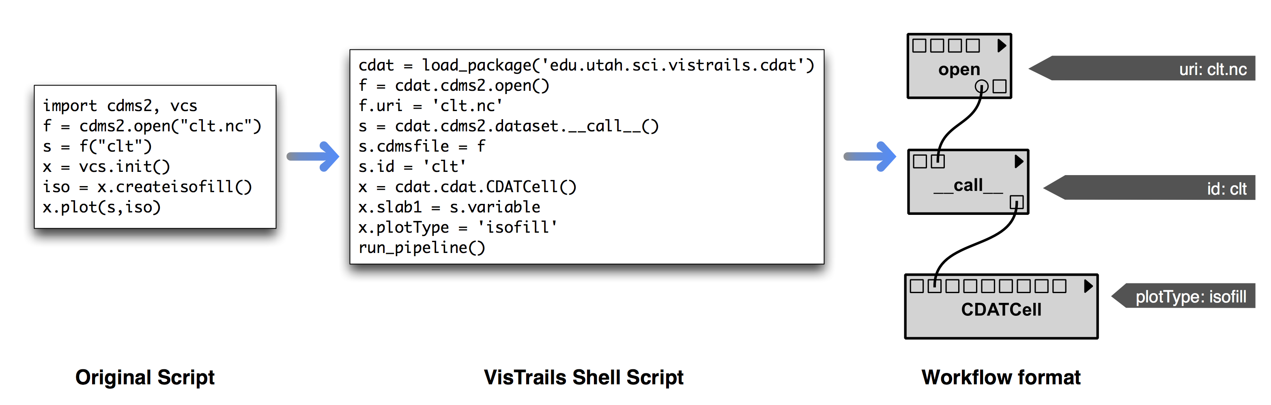

**Figure 13:** Simple UV-CDAT Python script opening a file and plotting a 2 dimensional contour plot

***Translate UV-CDAT Python scripts to workflow format:*** Migrating scripts to a provenance-enabled workflow format requires a two-step translation, as shown in the figure above. The first step comprises translating from original Python script to VisTrails Shell script, an intermediate format that will allow direct translation to the structured workflow format. The VCDAT window will generate Python commands (in original Python script format) according to the GUI actions performed by users, who will also use this mechanism directly to generate provenance.

***Advanced UV-CDAT provenance capture:*** The previous task will enable provenance capture for most basic UV-CDAT tasks (in particular those that use the CDAT and ParaView packages). In particular, it supports provenance for the VCDAT (GUI-based) interactions.

We plan to extend the VisTrails provenance architecture for use in UV-CDAT. The existing infrastructure is based on a layered architecture (Scheidegger et al., 2008a) that captures details of workflow evolution, individual workflows, and workflow execution logs. To support systematic maintenance of data provenance and ensure reproducibility, we will design a mechanism that provides reliable and persistent links between workflows and the data they generate. We will add flexible schemes so that application-specific provenance can be integrated into the provenance store. Because this information can help users understand previous analyses as well as construct new ones, mechanisms for querying provenance are essential. We will extend the VisTrails GUIs that query provenance information by example (Scheidegger et al., 2008b, Scheidegger et al., 2007) to support specific customizations for climate science applications. Starting late in year 1, and continuing in years 2 and 3, we will concentrate on extending the provenance capture API with these extensions.

#### Parallelism

#### Monitoring System

#### Supported Operating Systems on Personal Workstations to Supercomputers

### Test-Driven Agile Software Processes

Development of robust and stable code at large scale requires a sound software process. All the groups developing the major architecture components of UV-CDAT have their own software processes that have been unified as part of the overall software development effort. For the complete test-driven agile software processes, the UV-CDAT team has adopted and extended the model used by Kitware. For UV-CDAT’s develop of large libraries and packages, Kitware implemented its novel software processes based on methods from agile development and test-driven development. The processes incorporates source code control, using Git source code repository; build management, using CMake; and regression testing, using CTest and CDash. One of the highlights of this process is that it runs continuously, simultaneously on multiple platforms and produces its results on web-accessible dashboards. Thus, as software is checked into the source code repository, it is immediately tested and results posted. Developers rapidly obtain feedback on their changes and correct problems immediately. This process along with user access the code repository is demonstrated in Figure AA.



Figure AA. UV-CDAT’s Git source code revisions and test-driven agile software process.

As a first step towards introducing an agile software development process to UV-CDAT, we converted its build process to use CMake. This conversion allowed us to use CTest and CDash to test and monitor the development process.

UV-CDAT employs CMake 2.8’s ExternalProject module to build each of its approximately seventy dependencies libraries and packages. The ExternalProject module makes it easier to build external software components on which the project depends. An “external project” is one for which the source code is available, but is not necessarily part of the main build process. The ExternalProject_Add function makes it possible to say “download this project from the internet, run its configure step, build it and install it” in just a few lines of code in the CMakeLists.txt file. All of the time intensive processing that occurs for each step is deferred until build time.

The basic concept of ExternalProject is simple: given an external source of software (URL to a uv-cdat.tar.gz file, Git repository, or local directory), execute the sequence of commands necessary to build and install that software such that it can be referred to (include, link, run) from the main project.

By design, ExternalProject is modular and compact. With this we can easily extend UV-CDAT to build additional packages when the need arises. Additionally, just employing CMake as the build system of UV-CDAT allows us to very easily extend and customize its build process in a variety of ways. We can use CMake to give the users numerous build options, allowing a developer to easily build portions of UV-CDAT as needed. This allows us to achieve a requirement goal of distributing a UV-CDAT-lite (e.g., only building CDAT or components of CDAT such as CDMS).

#### Code Repository (Git and Github)

UV-CDAT developers are located throughout the United States at DOE facilities, universities, and private companies. To enable them to work together on the vision for large-scale analysis and visualization software, we provided the source code in an open source Internet-accessible revision control system called Git. With Git, UV-CDAT developers have write access to the software repositories, enabling them to make changes to the source code. Everyone has read access to the repositories, so you may download the most up-to-date stable or development version of the software. If you are looking for a stable release of the source code, you can download it from a separate branch of the distribution directory found at the following URL http://uv-cdat.org/. The UV-CDAT Git develop repository should only be accessed if you want to be on the bleeding-edge of the development effort. There are several ways to access the UV-CDAT Git repository:

* GitHub Web Access: If you just wish to browse around or download a few individual files or submit and check out bug fixes, the best tool is the web-based GitHub interface.
* Anonymous Git: To access the Git repository anonymously, you will need a Git client. You can access the entire UV-CDAT repository or choose the module you would like and check it out. For example, to get only the VisTrails module, use: “git clone git://vistrails.org/vistrails.git”
* Developer Git Access: We currently use HTTPS basic authentication for logging in to the Git repository, which requires a usersname and password.

For more help on using Git, consult the Git website or Git book. The website provides a [list of clients and useful links](http://subversion.tigris.org/project_links.html).

#### Software Installation (CMake)

**CMake** is a family of open-source tools designed to build, test and package software. CMake is used to control the software compilation process using simple platform and compiler independent configuration files. CMake generates native makefiles and workspaces that can be used in the compiler environment of the developer’s choice. CMake is quite sophisticated: it is possible to support complex environments requiring system introspection, pre-processor generation, code generation, template instantiation and cross-compilation.

#### Software Test Suite (CTest)

**CTest** is a testing tool distributed as a part of CMake. It can be used to automate updating (using SVN for example), configuring, building, testing, performing memory checking, performing coverage, and submitting results to CDash dashboard system.

#### Nightly Monitoring (CDash)

**CDash** is an open source, web-based software testing server. CDash aggregates, analyzes and displays the results of software testing processes submitted from clients located around the world.

### Secure Distributed Data Access

### Product Services

#### Climate Analysis Tools

##### Cdutil

Cdutil is another LLNL developed package that retains metadata information after some sort of data manipulation. It is geared toward climate specific applications such as time extraction, seasonal average, bounds setting, vertical interpolation, variable massager (i.e., prepping variables in order to compare them, such as masking/regridding), region extraction, and other similar functions.

##### Genutil

Genutil is a package developed by LLNL software developers to facilitate day-to-day climate analysis and diagnosis in UV-CDAT. These tools are not climate specific, but more “array” specific. (See Figure XX.) They are “metadata-smart” retaining metadata information after some sort of data manipulation (a UV-CDAT signature trademark). Example of Genutil tools include statistics, array growing (to expand a data array before comparing data with a different number of dimensions, (e.g. applying a 2D land/sea mask, to a 3D data set), color manipulation by name, status bars, string templates, selecting non-contiguous values across a dimension, and other such functions.

##### ESMF/ESMP

#### Visualizations Tools

##### DV3D

##### Matplotlib

##### ParaView

Support for computing the depth velocity from the horizontal velocity field was added to the vtkUnstructuredPOPReader. The POP code does not explicitly solve the vertical velocity, instead it computes from the divergence of the horizontal velocity field and the use of the continuity equation of fluid mechanics. The reader now computes this important derived field.



*Figure OOO: Visualization of Velocity on a Spherical Representation of the Earth using vtkUnstructuredPOPReader*

A projection filter to go from a sphere to the plate carree lat-lon projection was added. Cells that straddle the antimeridian (180 degrees longitude) are split and tensors are transformed to the projected coordinate system.

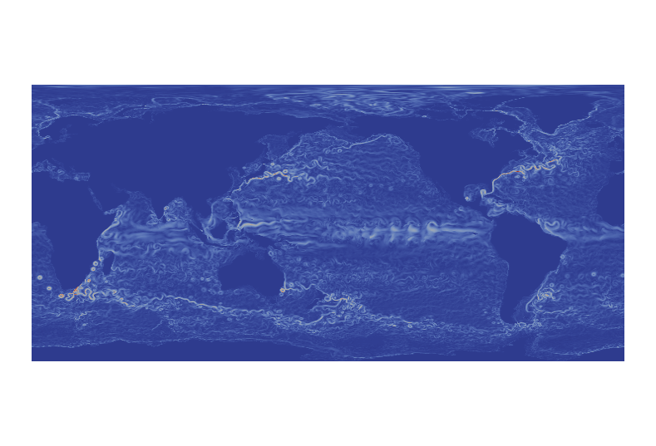

**Figure NNN***: Visualization of Velocity on a Flat Map (using Plate Carrée Projection)*

##### R

##### VCS

The Visualization and Control System (VCS) [Doutraiux, 2007] is the de facto standard 1D and 2D graphics package for UV-CDAT. It is especially designed for climate change research. Conforming to the netCDF CF convention, VCS allows users to have complete control over the graphics. That is, by specification of the desired netCDF CF data, the graphics method, and the display template, the user can control the appearance of the data display, associated text, and animation. Because it is so flexible, wide ranges of graphical displays are predefined and users can create and share new ones. For the community of MIPs (including CMIP), users have predefined graphical output specific to their diagnostic climate modeling needs.

##### VisIt

##### ViSUS

##### VTK

### Diagnostic Packages

Researchers are uneasy when it comes to sharing their diagnostics. They spend a lot of time putting them together to prove a point, to further the science, or for publication. In order to further prove or disprove climate phenomena, others use these diagnostics. Therefore, eventually bits and pieces of diagnostic codes can be (and are) exchanged with others in collaboration. However, the process of “adopting” a new diagnostic is a very arduous process on both the part of the diagnostic provider and user. Another harmful piecemeal diagnostics consequence is that multiple or similar (but not identical) versions of diagnostics are used, which produce slightly different results. Currently, these diagnostics are being continuously redeveloped to meet a specific I/O format, programming language, or simply because the user doesn’t trust external code. Through U-ReAD, UV-CDAT is trying to close that gap in diagnostic trust and reuse by providing a common environment for all researchers to develop in, and encouraging and facilitating communication and sharing in diagnostic development.

For the DOE Enterprise Earth System Modeling Project, there must be several packages that will run automated and interactive diagnostics on the model component simulation output for atmospheric, land, ocean, and sea-ice. UV-CDAT scripts have been created to generate data files required to interactively produce 600 + diagnostics and plots that are substantially equivalent to the batch output of the NetCDF Operators (NCO) Atmospheric Modeling Working Group (AMWG) diagnostics package. Unlike the NCO AMWG package with static plots, the UV-CDAT AMWG version allows for dynamic user interaction and data queries of the ESGF distributed archive. Interactively, the UV-CDAT functions allow such changes as contour intervals and colors, zoom to regional locations, and displaying multiple user selected plots on one or more canvas displays. Over the longer term, the diagnostics will be expanded to not only cover the Community Atmosphere Model (CAM) but also include the ocean, land, and polar climate model working groups in FY 14. UV-CDAT’s climatological and departures capabilities are used to generate the means of the simulations and its plot capabilities are used to produce plots and tables of mean climate in the NetCDF format and CF convention.

#### AMWG

As a component of the larger coupled Community Earth System Model (CESM), the CAM5 model produces atmospheric output that must be tested using unique diagnostics for calibration and validation. The diagnostics are woven together into a diagnostics package that computes climatological and departure means. These data output are then stored into a distributed archive for interactive manipulation. The output are used to compare against different CAM model simulation runs and observational and reanalysis data output. Examples of the diagnostics output include [list examples for the AMWG diagnostics]

#### LMWG

#### OMWG

Meridional Overturning Circulation (MOC) was identified as a Parallel Ocean Program (POP) diagnostic that was dropped by the Parallel Ocean Program users at LANL when they moved to a high resolution, 1/10 degree grid as the diagnostic was consuming too much compute time at that resolution. The diagnostic was then produced only when absolutely necessary, by post processing of prognostic fields using the same poorly performing code with the added cost of I/O. The UVDAT project targeted this diagnostic of the OMWG diagnostics package standard for parallelization making a substantial impact on the time to solution. This included support for LANL specific POP implementation of Partial Bottom Cells (PBC), a related diagnostic Meridional Heat Transport was also sped up and is computed simultaneously at very little cost. Speedups of serial versions are greater than 60x and parallel versions are substantially faster depending on I/O read performance taking less than a second to calculate the MOC when the requisite prognostics are in memory. The LANL POP team was pleased with post processing performance gains, and is currently working to reestablish this new parallel MOC and MHT as part of the LANL POP runtime diagnostic standard.

#### PCWG and MPAS

#### Metrics

The World Climate Research Programme (WCRP) has established a panel to foster the development of routine performance metrics for climate models. This panel, jointly established by the Working Group on Numerical Experimentation (WGNE) and the Working Group on Coupled Models (WGCM), has developed a package to quantify model errors (based on comparison with observations), and to assess the relative model performance of different models. The WGNE/WGCM metrics package is designed with UVCDAT, which is ideally suited for this purpose given its breadth of analysis capabilities. The package includes routines for computing standard metrics, carefully selected observation data sets, and a database of results from all models contributed to CMIP3 and CMIP5. The package is currently being evaluated by several modeling groups and will be widely distributed in September 2013. In the more than 20 years of WCRP model intercomparison projects, modeling groups have contributed their data with little information on how well their model compares to other state-of-the-art models. With the WGNE/WGCM metrics package, modeling groups will be able to test new versions of their model (see Figure BB) against others *during* the model development process. As the modeling community begins to work towards a CMIP6, the WGNE/WGCM metrics panel intends to broaden this model-data interrogation to include a diverse range of community-based metrics for Earth System Models.



**Figure BB**. Portrait diagram depicting the root mean-square error (RMSE) of the annual cycle for the CMIP5 Multi-Model Mean (MMM) and individual contributing models (columns), for each of a selection of atmospheric metrics (rows). A normalised value of positive (negative) 0.5 indicates an RMSE 50% larger (smaller) than the MMM.  For each entry, the upper left (lower right) triangles represent the model RMSE with respect to the following default (alternate) observational reference data sets: ERA­-INT (NCEP1-RNL) for upper air fields; CERES-EBAF (ERBE) for radiation; and GPCP (CMAP) for precipitation. Further additional discussion of the portrait plot, see Gleckler et al. (2008).

#### Uncertainty Quantification (UQ)

We have used Python scripts to wrap select C++/python tools from the UQTk toolkit (<http://www.sandia.gov/UQToolkit>) and make them accessible to UV-CDAT. The Uncertainty Quantification (UQ) Toolkit is a software library that facilitates the propagation of uncertain inputs and parameters through a computational model by using Polynomial Chaos expansions for random variables and stochastic processes. The tools connected to UV-CDAT include the recently developed iterative Bayesian compressive sensing (iBCS) algorithm [Sargsyan 2013], used in conjunction with polynomial chaos expansions to select the best basis sets and construct inexpensive surrogates for computationally expensive models. The surrogate models are used, without much computational overhead, in place of the expensive model, in global sensitivity studies for observables of interest. Figures "datbcs.png" and "senscirc.png" display data generated by UQTk tools accessed from within the UV-CDAT framework. Figure "datbcs.png" shows the distribution of surrogate model evaluations for Leaf Area Index (LAI), which is one of the observables generated by the Community Land Model (CLM).  Figure "senscirc.png" shows the most important CLM model parameters, with blue circles, and combination of parameters, with green lines, contributing to the variance in LAI. The circle sizes and line thicknesses are proportional to the importance of these parameters to LAI variance.

|  |  |
| --- | --- |
| Macintosh HD:private:var:folders:8B:8BSEjN2CFk4CXR3HnYFa0U+++TM:-Tmp-:TemporaryItems:datbcs.png | Macintosh HD:private:var:folders:8B:8BSEjN2CFk4CXR3HnYFa0U+++TM:-Tmp-:TemporaryItems:senscirc.png |

### Graphical User Interface

The UV-CDAT GUI is designed to be easy to use but still support a broad range of data exploration tasks. The building blocks for creating visualizations are variables and plots. Variables represents the data to analyze and can link to local files, remote files, or any of the other available data sources. Plots are methods for visualizing data. UV-CDAT contains a large selection of plot types for visualizing climate data. The basic usage is: First drag a variable to a spreadsheet cell, then drag a plot type to the same cell. The cell will then render the selected data with the selected plot type. Variables and plots can be dragged into a cell in any order. Using a queue system, variables are matched to plots based on the order they were dropped.

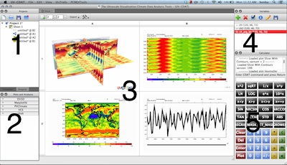

#### Variables

Variables represents the data to explore. Variables can be loaded either from local files, or from one of the supported data sources. These include ESGF, and NASA's DODS Catalog via OpenDAP. Loaded variables are shown in the upper right. The variable edit panel allows users to select subregions by either drawing a rectangle on a map around the region of interest, or by using the slider widgets to set bounds on each dimension individually. There is also a calculator pane (lower right), for performing simple calculations on variables such as getting the difference between two data sets or performing a regrid operation. Additional climate related tools and operations are available from the PCMDI Tools dropdown menu.

#### Plots

A plot is a method for visualizing data. The list of available plots is shown in the bottom left. A plot takes one or more variables as inputs, and have various parameters that can be adjusted using the Plot Properties panel to change the final result. Many plots also allow users to interactively explore specific parts of the visualization using their computer mouse. Several features exist to make plot comparison easier. For example, users are able to sync certain parameters between similar plots, like camera angle, and some plots can be overlaid atop one another.

#### The Spreadsheet

The spreadsheet (middle), which is based on the VisTrails spreadsheet, is a resizable grid where each cell can hold a visualization. Users drags variables and plots to cells in the spreadsheet. The spreadsheet enables visualizations to be compared and explored in groups. Using cell synching it is possible to modify multiple visualizations simultaneously, such as camera angle or cross-section sliders. The spreadsheet also supports undo/redo using he change-based provenance provided by VisTrails.

#### Projects

At the top left is the project panel. A project is a collection of variables, tagged visualizations, and spreadsheets. Each project can have multiple spreadsheets, each with multiple visualizations. A visualization in a cell can be tagged and reused in other cells or spreadsheets. All sheets, tagged visualizations and variables are saved with the project, along with all of the provenance information automatically captured by VisTrails.

#### Calculator

At the bottom right is the calculator panel. It consists of an output window at the top, followed by a command line input, and a grid of buttons below. Users can type commands using variable names, drag variables into the command line, or use the buttons to perform operations on variables. Any newly generated variables from these operations automatically appear in the variables panel and can be used to make new plots. Additionally, various raw Python commands can be entered here.

#### VisTrails

Users can bring up the full VisTrails window for any plot. This allows them to view detailed provenance information related to all user actions and workflow executions that were performed. The workflow generated for each plot can be edited here as well, allowing advanced users to tweak plots in ways that might not be available from the UV-CDAT GUI. Many more actions are available from the VisTrails window, visit www.vistrails.org for more information.

### Scripting

### Workflow and Provenance Generation

### Parallel Processing and Analysis Infrastructure

#### Batch Execution of Analysis and Visualization

#### Client-server parallel analysis

UV-CDAT provides several methods for performing parallel tasks, including data parallelism, task parallelism, and hybrid data/temporal parallelism. These methods include interactive and non-interactive visualization and analysis. Tools and features for accessing parallel methods include ParaView, VisIt, ParCat, and Distributed Arrays. Some components (e.g., methods for regridding using the ESMF component) can exploit parallelism in isolation from other components. In the latter case, the data movements are taken care within the scripting interface once a script is launched on a certain number of processors.

Large-scale data parallelism using ParaView or VisIt is enabled by a client-server architecture, in which a server is instantiated on a parallel capable machine, and the client connects to the server and communicates instructions to the server. For interactive sessions, the UV-CDAT GUI acts as a client, such that users can connect to the server by providing connection information in the GUI or the interactive Python shell provided by the GUI. Once the server has finished loading the data and processing it, the GUI is updated with the results of the parallel job.

Non-interactive batch processing is also available for parallel processing. UV-CDAT supports scripting in Python and calls parallel methods already compiled in C/C++/Fortran. Hybrid spatial–temporal parallelism is also available in ParaView by using the spatio-temporal pipeline in a batch-processing mode. The spatio-temporal pipeline can greatly increase parallel performance for data sets with large spatial and temporal resolutions. VisIt offers additional support for applying R algorithms in parallel to spatially partitioned data pieces. ParCAT delivers temporal parallelism capability (in batch) for high temporal resolution and smaller spatial extents data sets. Distributed arrays are a feature in UV-CDAT, which allows the computation and processing of large-scale arrays that would normally not fit on one node of memory.

Currently UV-CDAT supports numerous types of parallel processing, including data parallel, spatial, and temporal parallel processing capabilities. The goal of this task is to integrate these techniques and develop a general cyber infrastructure for processing big climate data for analysis and visualization purposes. Kitware, LLNL, and ORNL will co-lead the integration and continued development of the parallel data infrastructure to support processing, analysis, and visualization of big climate data. Our data parallelization work will focus on three core mechanisms.

The first mechanism uses UV-CDAT in batch execution in a “bag of tasks” model. Each compute node is assigned a distinct UV-CDAT workflow to execute. This workflow is beneficial for many common analysis tasks such as the processing of current generation model diagnostics in which individual diagnostic functions can be assigned to a single UV-CDAT process. Parallelization is achieved by running multiple UV-CDAT processes, and hence multiple diagnostic functions, concurrently across a large number of compute nodes.

The second mechanism provides parallelization of analysis and data summarization tasks across larger scale data sets in a batch post-processing mode. This uses the UV-CDAT ParCAT system that supports high-performance parallel I/O through libraries such as Parallel NetCDF and extremely efficient analysis operators developed using the Message Passing Interface (MPI) and native C routines. This parallel infrastructure is most suited for batch post-processing of very large-scale climate data sets across large-scale compute resources.

The third mechanism provides parallelization of analysis and visualization tasks across larger scale data sets for interactive and batch analysis. This mechanism will rely upon the client–server architecture of UV-CDAT coupled with ParaView. Together they will provide parallel analysis across both temporal and spatial domains directly using the mature ParaView analysis and visualization infrastructure while supporting the interactive analysis and visualization aspects of UV-CDAT.

Tasks performed under this section will include:

* Automation of common post-processing workflows such as diagnostics (see section 3 for provisional list of diagnostics);
* Parallelization of existing serial analysis algorithms;
* Develop new scalable analysis algorithms for high-resolution models;
* Developing an efficient means to submit remote jobs using open source tools;
* Improving UV-CDAT data structures for parallel data processing;
* Improving batch processing aspects of UV-CDAT;
* Integrating parallel infrastructure with GUI;
* Introducing Client–Server architecture for UV-CDAT; and
* Making ParaView data structures and CDMS interoperable.

### Server-side Analysis and Visualization

### Performance of Replication Client

### Monitoring Services

# Community Outreach

For the success of UV-CDAT, it is important that UV-CDAT becomes the de-facto open source tool for visualization and analysis of big climate data across the globe at various organizations, national labs, and universities. It also will benefit UV-CDAT technically, as it becomes part of other government and non-government projects. In order to realize this goal, the UV-CDAT team has taken a series of steps towards the next phase of UV-CDAT community outreach. One of these steps manages, electronically, libraries and packages using GitHub for manually registering and tracking bug reports and software updates. With our completely web-based system, adding bug reports and viewing fixes is as simple as filling in a few details on the UV-CDAT GitHub website and registering your bug report. Another step, educates users who are interested in learning more about and using UV-CDAT’s libraries and packages. Our “Tour” link on our new website provides a more detailed look at the many features and benefits of our integrated analysis software system. For more information on UV-CDAT, email us at [uvcdat-support@llnl.gov](mailto:uvcdat-support@llnl.gov) or visit our website at <http://uv-cdat.org/>.

## Workshops

UV-CDAT workshops focus on a range of issues revolving around both “user-centric” and “developer-centric” issues. These issues often reflect the dynamic needs of the broader community and help to shape future software development. Those that attend UV-CDAT workshops are keen to proactively address the: ***technical challenges***, such as developing and implementing open standards and interoperability between software components; ***legal challenges***, such as terms-of-use, group policies, or trust frameworks and new paradigms; ***usability challenges***, such as how application and user interfaces are created so that using and navigating different software components are made easy; ***social challenges***, such as determining how technologies, tools and services will impact social interactions; ***local hardware challenges***, such as supporting the many different operating systems on a host of flavored platforms; and ***server and cloud challenges***, such as how to work with a whole range of sever-side computing platforms connected via a complex globally distributed heterogeneous network—to name a few.

The first week of December 2013, UV-CDAT, in conjunction with the Earth System Grid Federation, will host its first international workshop. The focus of the workshop is to bring technologists and scientists interested in leveraging emerging technologies and solutions to support, enable and enhance climate and weather research. Of particular interest are individuals who are building infrastructures and tools to support data sharing, analysis and sharing of climate model output, observations, and reanalysis. U.S. principal investigators from DOE and NASA will organize the workshop along with international principal investigators from the Infrastructure for the European Network for Earth System Modelling (IS-ENES 2) project. This partnership envisions an environment that allows users open access to exabytes of model-generated, satellite, and in-situ data including physical, biogeochemical and ecosystem content. This infrastructure will bring to life a synchronized federation that supports models, observations, reanalysis, GIS integration, model intercomparison capabilities, user support and visualization, as well as a full suite of server-side analysis tools and integration with desktop and web-based productivity applications.

More information on the upcoming workshop can be found at the following URL link: [give link to the workshop].

## Online Tutorials

Online webinars are extremely popular as it enables the user to participate remotely. Also, webinars are part of the documentation. The average time for the online tutorials is between three and five minutes, and the average length of a sample quiz is no more than seven minutes. The tutorials are meant to be independent; therefore they can be viewed in random order. However, for new users, it is recommended that the user work through the first seven tutorials in order to get a general feel for the software package. Quizzes are optional and can be completed whenever time permits. Users also have the option of skipping the tutorials and go straight onto taking a quiz. Quiz scores are not sent or stored. The point of the online tutorial is to help you learn about UV-CDAT. Tutorials can be viewed as many times as needed and quizzes can be taken as many times as desired. Viewing online Tutorials only require a web browser and Internet connections.

The initial tutorials were created from the perception of what users would needed most to get started with UV-CDAT. Community suggestions for other tutorials are entered on the UV-CDAT website and the most listed request gets the highest priority for tutorial creation.

More information on online tutorials can be found at the following URL link: [give link to the workshop].

## Online Classes

There are many benefits to online UV-CDAT classes such as not having to travel anywhere, taking the course whenever one chooses, replaying any section of the course over for clarity or to refresh memory, and not wanting to be bothered by classmates with varying personalities. For the most part, UV-CDAT online classes are generally helpful for many of us that are too busy with work schedules and deadlines. Online classes are extremely popular in other fields, as it enables the user to participate remotely. Interactive online UV-CDAT classes are recorded and included as part of the documentation.

More information on online classes can be found at the following URL link: [give link to the workshop].

## Website Documentation

Continue to publish articles, journals, and books on UV-CDAT.

# Collaborative Governance

Collaborative governance is defined by Wikipedia as a process and a form of [governance](http://en.wikipedia.org/wiki/Governance) in which participants (parties, agencies, stakeholders) representing different interests are collectively empowered to make a [policy](http://en.wikipedia.org/wiki/Policy) decision or make recommendations to a final decision-maker who will not substantially change consensus recommendations from the group. Governance can employ different degrees of [public consultation](http://en.wikipedia.org/wiki/Public_consultation) and participation, ranging from non-participation (the community is unaware of any decisions taken), informing (telling the community what is planned and to understand problems, alternatives and solutions), [consultation](http://en.wikipedia.org/wiki/Public_consultation) (to obtain public feedback on analysis, alternatives and/or decisions), [collaboration](http://en.wikipedia.org/wiki/Collaboration) (to partner with the public to develop alternatives, identify preferred solutions, and make decisions), to empowerment (placing final decision-making into the hands of the public). Collaborative governance is governance with characteristics of both collaboration and empowerment. [Reference: <http://en.wikipedia.org/wiki/Collaborative_governance>]

For UV-CDAT, the governance direction is to take it from a benevolent Principal Investigator (PI) (or malevolent PI, depending on who you talk to) hierarchical governing body to a flat collaborative governing body. This will give UV-CDAT the longevity it needs to persist over time and the flexibility to adjust to the community’s short-term and long-term needs. The new governing body, called the UV-CDAT Review Board (URB), will be based on a group of individuals whose goals will be to advance UV-CDAT technology by providing direction and oversight to its development. While the open-source nature of UV-CDAT allows natural progression via its many contributors and collaborations, the board will provide synergy and cohesion among the various development efforts, thus ensuring that changes will benefit the community as a whole. The URB will serve the following functions:

* Maintain a roadmap of UV-CDAT, including long-term plans; and
* Make decisions on high-impact code changes to UV-CDAT.

The URB governance we have the makeup of: (1) a steering committee, funding agencies and stakeholders responsible for providing resources; (2) an executive committee, which has overall responsibility for meeting sponsors, stakeholders, and community needs and prioritizing work; and (3) a technical committee, responsible for the development of the system architecture, the management of the development lifecycle and scheduling releases. The executive and technical committees are responsible for setting release contents and reporting what was actually delivered in the releases to the community.

Code changes with a high impact on developers and/or users are to be reviewed by the URB committees. Guiding principles for deciding whether a change require URB involvement include:

* Will the change significantly affect backwards compatibility?
* Will the change significantly affect users, managers, or developers?
* Does the change significantly shift the functionality and scope of UV-CDAT?
* Are there any licensing issues?
* Are there any security concerns that need to be addressed?

Bug fixes do not in general require URB approval. Small feature additions do not require approval provided they are part of an associated development plan. In both cases, changes must be formally documented and published to the mailing list and/or tracking web sites (i.e., UV-CDAT’s GitHub site) for comment before implementation. Responsibilities and details on each URB committee are noted:

* ***Steering Committee (SC) Responsibility:*** Comprised of program managers whose agencies provide significant sources of identified and dedicated funding and resources for UV-CDAT development and core infrastructure. The SC provides a forum for UV-CDAT funding agencies to interact on a regular basis regarding the vision, goals, and progress of the UV-CDAT effort as they relate to each agency’s mission and plans. Agency representatives work with the UV-CDAT executive and technical committees to articulate UV-CDAT goals and formulate metrics that reflect programmatic requirements. The executive committee reports to the SC on the status of UV-CDAT development, adoption, and collaborations, and offers guidance as warranted. A program manager designated by the Climate and Environmental Sciences Division within the DOE Office of Science Biological and Environmental Research will initially **Chair** the SC. The **Chair** in consultation with other agency representatives who support UV-CDAT will determine the funding threshold for membership on the Steering Committee. Role of the steering committee:
  + Communicate agency objectives and constraints to the executive committee to ensure that they are reflected in UV-CDAT goals and vision.
  + Review and concur on UV-CDAT programmatic metrics proposed by the executive committee, and changes to those metrics as may be necessary from time to time.
  + Advise on funding issues and opportunities that may be relevant to continued progress.
  + Ensure significant sponsoring agencies are represented on the SC.
* ***Executive Committee (EC) Responsibility:*** General guidance and overall high-level decisions in directing the course of the UV-CDAT project in correspondence with multiple sponsor and stakeholders needs—ultimate responsibility for ensuring that UV-CDAT meets the needs of customers and stakeholders. Future EC membership shall develop organically from the EC itself. EC members are responsible for nominating new members, who are elected by consensus or majority vote (with the **Chair** breaking any tie). Members may step down from the EC at any point. Members may be expelled from the EC by consensus or vote if they are unable to attend meetings after reasonable effort has been made to contact them, or if their actions are found to be counterproductive to the purposes of the URB. The executive committee is responsible for organizing and interacting with the UV-CDAT Steering, Technical and Advisory committees. The steering committee—composing of sponsors, stakeholders, and users—provides input to the EC on the entire UV-CDAT project and path forward from their perspective. This input will be interpreted and used to provide requirements to the technical committee. The executive committee **Chair** must attend all steering committee meetings. The **Chair**, when permitted, will attend all technical committee meetings to provide input. Role of the executive committee:
  + Setting the strategic direction of the UV-CDAT project.
  + Oversight of technical committee (and other committees as defined by the executive committee).
  + Work with Technical Committee to review implantation plan for strategic goals.
  + Approval of major architectural changes.
  + Appoint an Advisory Committee of users and external stakeholders who will provide feedback to the EC and technical committee on plans and suggestions for new directions.
* ***Technical Committee (TC) Responsibility:*** Guidance and direction on technical issues set by executive committee requirements—focused on technical aspects of UV-CDAT. Future TC membership shall develop organically from the TC itself. TC members are responsible for nominating new members who are elected by consensus or majority vote (with the **Chair or co-Chairs** breaking any tie). Technical members may step down from the TC at any point. Members may be expelled from the TC by consensus or vote if they are unable to attend meetings after reasonable effort has been made to contact them or if their actions are found to be counterproductive to the purposes of the URB. The **Chair** or **co-Chairs** will attend all executive and technical committee meetings to provide input. Role of the technical committee:
  + Requirements analysis (interfaces with customers - users - to understand requirements).
  + Technical architecture.
  + Organizing development.
  + Testing and releases.

The full UV-CDAT governance document can be seen on the UV-CDAT website or go to the following URL: <http://uv-cdat.org/governance/>.

# The Future of UV-CDAT

Many challenges remain for the UV-CDAT team, and new ones will emerge as more diverse data sets become available from climate simulations run on ever-increasing high-performance computing (HPC) platforms and from increasingly powerful, higher-resolution satellites and instruments. From these current and future challenges, UV-CDAT envisions an analytic and informatics infrastructure, which provides advanced user support, community outreach, diagnostic packages, big data and parallel data processing, web and server-side informatics and visualization, improved scripting capabilities, and more analytics and visualizations. By combining with other community tools, UV-CDAT seeks to strengthen the entire scientific community with advances that will be beneficial for all. In addition, the team will focus efforts on expanding into new areas of data mining, parallel provenance and metadata, workflows, HPC, cluster computing, and analysis over a distributed network. Furthermore, we intend to fully explore the possibility of providing a configurable and scalable UV-CDAT environment that can be easily deployed on the Cloud, so that resources and services can be instantiated on demand for specific short-lifetime projects, or to meet other requirements such as elastic allocation of computing processes. As future computing platforms, satellites, and instruments expand and reach extraordinary speeds and levels; we anticipate that in the coming decade UV-CDAT software will migrate from managing petabytes to exabytes of analytic data. Some of the most prominent future activities include:

* **User Support:** UV-CDAT users and developers support (documentation, tutorials, website updates and maintenance, support for platforms, monitor system tools usage, etc.). Community engagement for requirements, adoption & feedback.
* **Community Outreach:** Community engagement in the form or workshop, governance, literature, etc.
* **Diagnostic Packages:** AMWG, LMWG, OMWG, PCWG, and MPAS diagnostic packages to be developed along with other to be determined diagnostics.
* **Big Data / Parallel Data Processing Architecture:** Three parallel processes have been identified for running batch and interaction parallel processes along with client-server parallel interaction.
* **Web and Information Visualization:** Advance UV-CDAT analysis and visualization capabilities to a Web application.
* **Software Process:** Continue to build upon and improve UV-CDAT’s build, test, and documentation processes.
* **Refactor Code to make it Easier to Add Functionality:** simplifying the extendable and pluggable feature to support the addition of new codes.
* **Interface Enhancements:** Partnerships with climate science community to improve the user experience.
* **Improve Scripting:** Improve workflow scripts and user-controlled parameters.
* **Improve Visualization:** Develop new 2D and 3D visualization and interface for the BER climate community.

For DOE Enterprise Earth System Modeling Project, there must be a package that will run automated and interactive diagnostics on the output. UV-CDAT and Python scripts will be written to generate the data files required to produce the 600 + diagnostics and plots that are now created by the AMWG diagnostics package in batch mode. Unlike the existing AMWG package with static plots, the UV-CDAT team envisions dynamic user interaction and query through the UV-CDAT interface to allow functions such as changing contour intervals and colors, zoom to regional refinement, and displaying multiple user selected plots on one canvas. Over the longer term, the diagnostics will be expanded to not only cover CAM but also include the ocean, land, and polar climate model working groups in FY 14. UV-CDAT’s climatological and departures capabilities will be used to generate the means of the simulations and its plot capabilities we be used to produce plots and tables of mean climate in the NetCDF/CF format and convention.

Currently UV-CDAT supports numerous types of parallel processing, including data parallel, spatial, and temporal parallel processing capabilities. The future vision is to integrate these techniques and develop a general cyber infrastructure for processing big climate data for analysis and visualization purposes. The team will integration and continued development of the parallel data infrastructure to support processing, analysis, and visualization of big climate data. Our data parallelization work will focus on three core mechanisms:

1. *First mechanism* - batch execution in a “bag or tasks” model;
2. *Second mechanism* - parallelization of analysis and data summarization tasks across larger scale data sets in a batch post-processing mode; and
3. *Third mechanism* - parallelization of analysis and visualization tasks across larger scale data sets for interactive and batch analysis.

Delivering a sophisticated interactive and web version of UV-CDAT is essential for the developing a cyber-infrastructure to enable user platform independent high-performance visualization and analysis. The future goal is to exploit recent advancements in software and hardware web framework made possible vi Kitware’s ParaViewWeb (reference: http://pvw.kitware.com) and XDATA (reference: http://xdata.kitware.com) projects. These new advances will also help port UV-CDAT to new devices such as a mobile phones, iPads, tablets, etc.

[**MORE FUTURE ACTIVITIES**]

To prepare for such an expansion—with continual analysis of a comprehensive end-to-end solution for the overall increase in scientific productivity—UV-CDAT is also partnering with other private industry and universities in an effort to make substantial investments in data-driven software and technologies paramount for future computing platforms and ultrascale data archives.

# References

[CF, 2009]: CF, Climate and Forecast (CF) metadata convention for processing and sharing data files (2009). http://cf-pcmdi.llnl.gov/.

[CMOR, 2009]: CMOR, the Climate Model Output Rewriter produces CF-compliant netCDF data files (2009). http://www2-pcmdi.llnl.gov/cmor.

[Doutriaux, 2007]: Doutriaux, Charles, Drach, Robert, Williams, Dean, 2007: The Visualization and Control System (VCS), http://www2-pcmdi.llnl.gov/cdat/first-page/cdoutrix/beginners-guide/data-visualization/?searchterm=VCS.

[Drach, 2007]: Drach, Robert, Dubois, Paul, and Williams, Dean, 2007: Climate Data Management System, version 5.0, http://www2-pcmdi.llnl.gov/cdat/manuals/cdms5.pdf.

[HDF Group, 2009]: HDF Group, HDF: a file format used for storing various forms of data (e.g., raster, scientific, etc.) (2009). http://www.hdfgroup.org/.

[PP, 2013]: PP-format is a record-based binary format used in a number of the BADC's data sets. It is a Met Office proprietary format so is mainly associated with Met Office products. http://badc.nerc.ac.uk/help/formats/pp-format/index.html.

[Sargsyan, 2013]: Khachik Sargsyan, Cosmin Safta, Habib N. Najm, Bert J. Debusschere, Daniel Ricciuto, Peter Thornton, “Dimensionality Reduction for Complex Models via Bayesian Compressive Sensing”, accepted for publication, International Journal for Uncertainty Quantification, 2013.

[Taylor, 2011]: Karl E. Taylor, Ronald J. Stouffer, Gerald A. Meehl, “An Overview of CMIP5 and the Experiment Design”, *Bull. Amer. Meteor. Soc.*, **93**, 485–498. doi: http://dx.doi.org/10.1175/BAMS-D-11-00094.1

[UCAR, 2008]: UCAR, University Corporation for Atmospheric Research, netCDF: a machine-independent, self-describing, [binary](http://en.wikipedia.org/wiki/Binary_file) data [format](http://en.wikipedia.org/wiki/File_format) (2008). http://www.unidata.ucar.edu/software/netcdf.

[WMO, 2009]: WMO, World Meteorological Organization standardized the GRIdded Binary (GRIB) data format commonly used in meterology to store historical and forecast weather data (2009). http://www.grib.us/.

1. Enabling Technologies and Collaborations

Partnerships and our intent to collaborate reflects close relationships to a wide variety of data, science, and technology efforts that position UV-CDAT to make a major impact on the progress of science in: (a) IPCC AR5, (b) DOE Enterprise Earth System Modeling Project, (c) the European IS-ENES G8 project, and (d) future geoscience project in need of analytics and informatics infrastructure.

We have had preliminary and in-depth discussions with a large number other groups proposing analytic data centers and institutes with strong interests in collaborating. In most cases, these projects would be developing tools and technologies that would be useful to the UV-CDAT, and in some cases there is an interest in generalizing and enhancing UV-CDAT developed technology and disseminating it to a larger audience. For many on the collaboration, our project will be vital for their national and international programs and projectsto reach their goals. For this reason, we have well positioned UV-CDAT team members that overlap in services and institutions and will represent our project as liaisons between many of the disparate organizations. Examples of some of our collaborations are described below.

Our diverse team members are uniquely qualified to enable disparate technologies and to collaborate with outside entities, including other governmental agencies, universities, private companies, and individuals. These enabling technologies and collaborations include investigators with both technical and scientific expertise as well as representatives from modeling and data centers. Together, our collective knowledge includes large distributed data and software systems (such as ESGF) and a wide range of analytic and informatics management systems combined under one infrastructure. That said, the team is in close collaborations with other synergistic software projects and is collaborating, as proposal partners, with outside national and international agencies. One of many collaborations includes NASA’s ***I***ntegrated ***C***limate ***A***nalysis *D*ist***r***ib***u***ted ***S***ervices (ICARUS). ICARUS’ main goal is to facilitate the joint discovery and analysis of NASA satellite observations and climate model output. As reported in literature, satellite observations are a key to understanding why long and medium term predictions from different models diverge, even when the models are run with the same assumptions about future human development and anthropogenic emissions. ICARUS will remove all current roadblocks to the usage of observations by providing an integrated platform where models and observations are accessed through the same services and with the same semantics. We will specifically target the global community of thousands of users that have already enrolled for access to CMIP5 model output stored and served by the ESGF. By addressing this existing community, we will establish a state of practice that will carry on for future CMIPs and IPCC reports, thus guaranteeing an ever- increasing relevance of NASA observations for DOE climate change research.

As a building block for Nation Science Foundation (NSF) efforts, UV-CDAT has the potential to create a well-connected environment that integrates NSF’s set of scientific computing libraries and application to foster more efficient analytics use by its scientific community. These building blocks capture using UV-CDAT: (1) as a potential NSF’s EarthCube building block where DOE and NSF share in a joint vision for large-scale analysis and visualization for both observational and model-generated climate data, with the aim of delivering new geoscience capabilities into the hands of scientists to foster more efficient knowledge discovery; (2) as a NSF ClimateTranslator building block where, through an API, the flexible translator assists in analysis, evaluation, synthesis and interpretation while capturing provenance and metadata to ensure reproducibility; and (3) as a NSF software infrastructure for sustained innovation where UV-CDAT’s pluggable framework of open source analytics and computation services and tools would be deployable in a cloud environment to provide functionality essential for broad range “big data” scientific computing.

[ADD OTHER CURRENT OR POTIENTIAL COLLABORATIONS]

1. Outreach, Papers, Presentations, Poster, Reports, and
2. Animations

To effectively build an infrastructure capable of dealing with large-scale data analysis and visualization, we had established connections with other funded DOE Office of Science projects and national and international programs and agencies at various meetings, workshops and conferences. This section describes many of the substantive interactions we’ve had during the short life of the UV-CDAT funded project.

* 1. Outreach Activities
* Charles Doutriaux and Dean Williams are hosting the UV-CDAT Face-to-Face Meeting to be held at LLNL the first week of December. This is a joint collaborative meeting between DOE, NASA, and the European IS-ENES G8 project. The focus of this meeting will be to bring together technologists and scientists interested in leveraging emerging technologies and solutions to support, enable and enhance climate and weather research. Of particular interest are individuals who are building infrastructures and tools to support data sharing, analysis of climate model output, observations, and reanalysis.
* Dean Williams hosted the LLNL, PMEL, and NOAA Development Meeting to join UV-CDAT and NOAA’s Ferret analysis and visualization activities. The meeting was held at Lawrence Livermore National Laboratory in Livermore, California, March 2011.
  1. Papers

B.2.1 October 1, 2012 through September 30, 2013

* Boonthanome Nouanesengsy, John Patchett, James Ahrens, Andrew Bauer, Aashish Chaudhary, Berk Geveci, Ross Miller, Galen M. Shipman, and Dean N. Williams. "Optimizing File Access Patterns through the Spatio-Temporal Pipeline for Parallel Visualization and Analysis". Submitted to LDAV 2013.
* Dean N. Williams, Gavin Bell, Charles Doutriaux, Andrew C. Bauer, Aashish Chaudhary, Harinarayan Krishnan, Michael Wehner, Boonthanome Nouanesengsy, John Patchett, Gerald L. Potter, Thomas P. Maxwell, Wei-Chen Chen, George Ostrouchov, Dave Pugmire, Galen M Shipman, Brian E. Smith, Chad A. Steed, Alexander Pletzer, “Climate Science ‘Big Data’ Parallel Analysis: Analyzing Mult-Model Climate Simulation Data”, IEEE Parallel and Distributed Systems, under peer-review, due out in 2013.
* Chad A. Steed, Daniel M. Ricciuto, Galen Shipman, Brian Smith, Peter E. Thornton, Dali Wang, Xiaoying Shi, Dean N. Williams, “Big Data Analytics for Earth System Simulation Exploratory Analysis”, Computers & Geosciences, under peer-review, due out in 2013.
* Luca Cinquini, Daniel Crichton, Chris Mattmann, Gavin M. Bell, Charles Doutriaux, Bob Drach, Dean Williams, John Harney, Galen Shipman, Feiyi Wang, Philip Kershaw, Stephen Pascoe, Rachana Ananthakrishnan, Neill Miller, Estanislao Gonzalez, Sebastian Denvil, Mark Morgan, Sandro Fiore, Zed Pobre, Roland Schweitzer, “The Earth System Grid Federation: An Open Infrastructure for Access to Distributed Geospatial Data”, IEEE special issue of FGCS (Future Generation Computing Systems), under peer-review, due out in 2013.
* Dean Williams, “Dealing with Data Overload in the Scientific Realm”, Science & Technology Review, January/February 2013, <https://str.llnl.gov/january-2013/williams>, <https://str.llnl.gov/january-2013>.
* Benjamin D. Santer, Jeffrey F. Painter, Carl A. Mears, Charles Doutriaux, Peter Caldwell, Julie M. Arblaster, Philip J. Cameron-Smith, Nathan P. Gillett, Peter J. Gleckler, John Lanzante, Judith Perlwitz, Susan Solomon, Peter A. Stott, Karl E. Taylor, Laurent Terray, Peter W. Thorne, Michael F. Wehner, Frank J. Wentz, Tom M. L. Wigley, Laura J. Wilcox, and Cheng-Zhi Zou, “Identifying Human Influences on Atmospheric Temperature”, Proceedings of the National Academy of Sciences (PNAS) 2013 110 (1) 26-33; January 2, 2013, doi:10.1073/pnas.1210514109.
* Brian Smith, Daniel M. Ricciuto, Peter E. Thornton, Galen Shipman, Chad Steed, and Dean Williams. ParCAT: Parallel Climate Analysis Toolkit. In Proceedings of the International Conference on Computational Science, pp. 2367–2375, June 2013. doi:10.1016/j.procs.2013.05.408
* Dean N. Williams, Timo Bremer, Charles Doutriaux, John Patchett, Galen Shipman, Blake Haugen, Ross Miller, Brian Smith, Chad Steed, E. Wes Bethel, Hank Childs, Harinarayan Krishnan, Michael Wehner, Claudio T. Silva, Emanuele Santos, David Koop, Tommy Ellqvist, Huy T. Vo, Jorge Poco, Berk Geveci, Aashish Chaudhary, Andrew Bauer, Alexander Pletzer, Dave Kindig, Gerald L. Potter, Thomas P. Maxwell, “The Ultra-scale Visualization Climate Data Analysis Tools: Data Analysis and Visualization for Geoscience Data,” *Computer*, 27 March 2013. IEEE Special Issue: Cutting-Edge Research in Visualization. IEEE computer Society Digital Library. IEEE Computer Society, <http://doi.ieeecomputersociety.org/10.1109/MC.2013.119>.
* Dean N. Williams, Ian T. Foster, Bryan Lawrence, Michael Lautenschlager, Don E. Middleton, “Earth System Grid Federation: Infrastructure to Support Climate Science Analysis as an International Collaboration”, Chapter in Data Intensive Science: Critchlow, Terence and Kleese-Van Dam, Kerstin, Editors. Chapman & Hall/CRC Computational Science, 2013, <http://www.crcpress.com/product/isbn/9781439881392>.
* Brian Summa, Attilay Gyulassy, Peer-Timo Bremer, and Valerio Pascucci, “Interactive Data Exploration” Chapter in Data Intensive Science: Terence Critchlow, and Kerstin Kleese van Dam, Editors. Chapman & Hall/Crc Computational Science, 2013, <http://www.crcpress.com/product/isbn/9781439881392>.
* Brian Smith, Daniel M Ricciuto, Peter E Thornton, Galen Shipman, Chad Steed, Dean Williams, and Michael Wehner 2013 International Conference on Computational Science, Fourth Workshop on Data Mining in Earth System Science (DMESS) 2013.
* Emanuele Santos, Jorge Poco, Yaxing Wei, Shishi Liu, Bob Cook, Dean N. Williams, and Claudio T. Silva, “UV-CDAT: Analyzing Climate Data sets from a User’s Perspecive”, IEEE Computing in Science and Engineering: Visualization Corner, vol 15 (1), pp. 94-103, January 1, 2013. ISBN No. 1521-9615. DOI: http://doi.ieeecomputersociety.org/10.1109/MCSE.2013.15.

B.2.2 October 1, 2011 through September 30, 2012

* Thomas P. Maxwell, “*Exploratory Climate Data Visualization and Analysis Using DV3D and UV-CDAT*”, IEEE Computer Society, SCC '12 Proceedings of the 2012 SC Companion: High Performance Computing, Networking Storage and Analysis, pages, 483-487, 2012, ISBN: 978-0-7695-4956-9 doi>[10.1109/SC.Companion.2012.69](http://dx.doi.org/10.1109/SC.Companion.2012.69). <http://www.nas.nasa.gov/SC12/demos/demo21.html>
* S. Kumar, V. Vishwanath, P. Carns, J.A. Levine, R. Latham, G. Scorzelli, H. Kolla, R. Grout, R. Ross, M.E. Papka, J. Chen, V. Pascucci. “*Efficient data restructuring and aggregation for I/O acceleration in PIDX*”, In Proceedings of the International Conference on High Performance Computing, Networking, Storage and Analysis (SC12), IEEE Computer Society Press, pp. 50:1--50:11. 2012.
* Shusen Liu; Levine, J.A.; Bremer, P.; Pascucci, V., "*Gaussian mixture model based volume visualization*", Large Data Analysis and Visualization (LDAV), 2012 IEEE Symposium on , vol., no., pp.73-77, 14-15 Oct. 2012. BEST PAPER AWARD.
* Wong, Pak Chung; Shen, Han-Wei; Pascucci, Valerio, Editors of special issue on "*Extreme-Scale Visual Analytics*", IEEE Transactions on Computer Graphics and Applications, vol.32, no.4, July-Aug. 2012.
* V. Pascucci, G. Scorzelli, B. Summa, P.-T. Bremer, A. Gyulassy, C. Christensen, S. Philip, S. Kumar. “*The ViSUS Visualization Framework*”, In High Performance Visualization: Enabling Extreme-Scale Scientific Insight, Chapman & Hall/CRC Computational Science, Ch. 19, Edited by E. Wes Bethel; Hank Childs, Lawrence Berkeley National Laboratory, Berkeley, California, USA; Charles Hansen, University of Utah, Salt Lake City, USA, Chapman and Hall/CRC, 2012.
* Gyulassy, A.; Kotava, N.; Kim, M.; Hansen, C.D.; Hagen, H.; Pascucci, V., "*Direct Feature Visualization Using Morse-Smale Complexes*", Visualization and Computer Graphics, IEEE Transactions on , vol.18, no.9, pp.1549-1562, Sept. 2012.
* Harsh Bhatia, Shreeraj Jadhav, Peer-Timo Bremer, Guoning Chen, Joshua A. Levine, Luis Gustavo Nonato, and Valerio Pascucci. Flow Visualization with Quantified Spatial and Temporal Errors using Edge Maps. IEEE Transactions on Visualization and Computer Graphics (TVCG), vol. 18, no. 9, pp. 1383-1396, Sept. 2012.
* Widanagamaachchi, W.; Christensen, C.; Bremer, P.-T.; Pascucci, V., "*Interactive exploration of large-scale time-varying data using dynamic tracking graphs*", Large Data Analysis and Visualization (LDAV), 2012 IEEE Symposium on , vol., no., pp.9-17, 14-15 Oct. 2012. BEST PAPER AWARD FINALIST.
* Tierny, J.; Pascucci, V., "*Generalized Topological Simplification of Scalar Fields on Surfaces*", Visualization and Computer Graphics, IEEE Transactions on Visualization and Computer Graphics, vol.18, no.12, pp.2005-2013, Dec. 2012.
* E. Santos, D. Koop, T. Maxwell, C. Doutriaux, T. Ellqvist, G. Potter, J. Freire, D. N. Williams, and C. T. Silva, "Designing a provenance-based climate data analysis application." In Provenance and Annotation of Data and Processes, vol. 7525 of Lecture Notes in Computer Science, Springer, 2012.
* Chad A. Steed, Galen Shipman, Peter Thornton, Daniel Ricciuto, David Erickson, and Marcia Branstetter, "Practical Application of Parallel Coordinates for Climate Model Analysis," In Proceedings of the International Conference on Computer Science-Workshop on Data Mining in Earth System Science, June 2012, pp. 877-886. DOI: 10.1016/j.procs.2012.04.094.
* Williams, S., Petersen, M., Hecht, M., Maltrud, M., Patchett, J., Ahrens, J. and Hamann, B. (2012), “Interface Exchange as an Indicator for Eddy Heat Transport”, Computer Graphics Forum, 31: 1125–1134. doi: 10.1111/j.1467-8659.2012.03105.x.

B.2.3 October 1, 2010 through September 30, 2011

* Williams, S., Hecht, M., Petersen, M., Strelitz, R., Maltrud, M., Ahrens, J., Hlawitschka, M. and Hamann, B. (2011), "Visualization and Analysis of Eddies in a Global Ocean Simulation," Computer Graphics Forum, 30: 991-1000. doi: 10.1111/j.1467-8659.2011.01948.x
* Williams, S.; Petersen, M.; Bremer, P.-T.; Hecht, M.; Pascucci, V.; Ahrens, J.; Hlawitschka, M.; Hamann, B.; , "Adaptive Extraction and Quantification of Geophysical Vortices," Visualization and Computer Graphics, IEEE Transactions on , vol.17, no.12, pp.2088-2095, Dec. 2011oi: 10.1109/TVCG.2011.162
* B.D. Santer, C. Mears, C. Doutriaux, P.J. Gleckler, S. Solomon, T.M.L. Wigley, N.P. Gillett, D. Ivanova, T.R. Karl, J.R. Lanzante, G.A. Meehl, P.A. Stott, K.E. Taylor, P.W. Thorne, M.F. Wehner, and F.J. Wentz, “Separating Signal and Noise in Atmospheric Temperature Changes: The Importance of Timescale”, *Journal of Geophysical Research* (Atmospheres), vol. 116, issue D22, November 2011. DOI: 10.1029/2011JD016263.
  1. Presentations
* Gerald Potter and Tom Maxwell presented UV-CDAT at the meeting titled, “*An Update on Obs4MIPs and Ana4MIPs: Part 2*”, held at Langley Research Center in Hampton VA, June 2013.
* Gerald Potter and Tom Maxwell presented UV-CDAT at the meeting titled, “*An Update on Obs4MIPs and Ana4MIPs: Part 1*”, held at Langley Research Center in Hampton VA, May 2013.
* Dean Williams and Claudio Silva presented and represented UV-CDAT at the Center for Urban Science + Progress (CUSP) Data Reproducibility Meeting held in Brooklyn, NY at NYU-Poly, May 2013
* Tom Maxwell and Gerald Potter presented UV-CDAT at numerous NASA meetings, on behalf of the development team. These NASA Goddard Space Flight Center (GSFC) presentations were held at:
  + The NASA Center for Climate Simulation (NCCS), March 2013
  + The GSFC/ Goddard Earth Sciences-Data and Information Service Center (GES-DISC), March 2013
  + The National Center for Environmental Prediction (NCEP), March 2013
  + NASA GSFC, December 2012
  + The NASA/Global Modeling Assimilation Office (GMAO), December 2012
  + NCEP, December 2012
* Dean Williams presented UV-CDAT at the Statistical and Applied Mathematical Sciences Institute (SAMSI)/NCAR Workshop on Massive Data sets in Environment and Climate Science, held at the Mesa Lab at NCAR in Boulder CO, February 2013.
* Charles Doutriaux, Tom Maxwell, Gerald Potter, and Dean Williams presented UV-CDAT on three separate occasions at the AGU Fall Meeting held in San Francisco CA, December 2012.
* Dean Williams and Robin Goldstone presented UV-CDAT at the 2012 BER Energy Sciences Network (ESnet) Requirements Review held in the Washington D.C. area, November 2012.
* Charles Doutriaux, Gerald Potter, and Dean Williams presented UV-CDAT at the 2nd Annual Earth System Grid Federation (ESGF) Conference held at Lawrence Livermore National Laboratory in Livermore CA, November 2012.
* Dean Williams presented UV-CDAT and ESGF as an invited speaker to Argonne National Laboratory, in Argonne IL, November 2012.
* Gerald Potter presented ESGF and UV-CDAT, as an update on Obs4MIPs and Ana4MIPs, at the “*Sounder Science Team Meeting*”, Greenbelt MD, November 2012.
* Dean Williams presented UV-CDAT working within the CSSEF testbed at the CSSEF Face-to-Face Meeting in the Washington D.C. area, November 2012.
* Dean Williams presented the “*Data Analysis and Visualization: UV-CDAT*” developments at the G8 Initiative ExArch (IS-ENES-2) Kickoff meeting. The meeting was held in London, UK at the Royal Adelaide Hotel, October 2012.
* Gerald Potter presented UV-CDAT and DV3D at the “*Clouds and the Earth’s Radiant Energy System (CERES) Science Team Meeting*”, held at the Geophysical Fluid Dynamics Laboratory (GFDL) in Princeton NJ, October 10, 2012.
* Dean Williams presented UV-CDAT at the 2012 Second International Workshop on “*Climate Informatics*” held at the NCAR’s Institute for Mathematics Applied to Geosciences in Boulder, Colorado, September 2012. At the workshop, members of the organization committee from universities expressed interested in collaborating with in the development of UV-CDAT. In particular, Cal Tech was interested in including their observational diagnostics into UV-CDAT.
* Dean Williams presented the “*Climate Analytics, Informatics, and Management Systems: BER Data Projects, Software, and Tools*” on behalf of the community. The meeting was held at the Gaithersburg Marriott Washington Center in Gaithersburg, MD, September 2012. UV-CDAT was presented alongside other BER software supported projects, such as CMOR, ESGF, testbeds, etc.
* Dean Williams presented ESGF/UV-CDAT at the Institute for Computing in Science (ICIS) “Big Data and Long Tails” Workshop, held in Park City Utah, August 2012.
* Chad A. Steed, “*Visual Analytics for Climate Model Analysis*”, invited presentation to the Naval Research Laboratory, Stennis Space Center, MS. July 2012.
* Dean Williams presented ESGF/UV-CDAT at the DOE BER Climate and Environmental Sciences Division (CESD) and DOE ASCR Data Intensive meeting discussions held in Germantown, MD, June 2012.
* Chad A. Steed, “*Visual Analytics for Climate Analysis*”, invited presentation to the Tennessee Valley Authority (TVA) River Forecast Center, Knoxville, TN, May 2012.
* Chad A. Steed, “*Visual Analytics for Climate and Text Analysis*” invited seminar presentation to the University of Tennessee Center for Intelligent Systems and Machine Learning (CISML), Knoxville, TN. April 2012.
* Chad A. Steed, “*Visual Analytics for Climate and Text Analysis*”, invited seminar presentation to the Mississippi State University Computer Science and Engineering Department, Starkville, MS. April 2012.
* Dean Williams presented ESGF/UV-CDAT at the Earth System Prediction Capability (ESPC) workshop held at the NOAA Science Center in Silver Spring, MD, March 2012.
* Chad A. Steed, “*Visual Analytics Tools for CLM*”, workshop presentation to the Joint Land and Biogeochemistry Working Groups, NCAR Mesa Lab, Boulder, CO, March 2012.
* Dean Williams presented UV-CDAT at the larger CSSEF Workshop meeting in Washington, D.C. held February 2012.
* Dean Williams presented and represented UV-CDAT at the LLNL General Electric collaboration meetings held February through June 2012.
* Dean Williams presented UV-CDAT at the CSSEF Face-to-Face Meeting held in the Washington D.C. area, January 2011.
* Dean Williams presented UV-CDAT at the Scientific Collaborations for Extreme-Scale Science Workshop, held at the Gaithersburg Marriott Washington Center in Gaithersburg, MD, December 2011.
* Dean Williams presented UV-CDAT at the 2011 AGU Fall Meeting (at the DOE BER Town Hall meeting) held in San Francisco, CA, December 2011.
* Dean Williams presented UV-CDAT at the DOE Climate Model Meeting, in Washington D.C. area, September 2011.
* Dean Williams presented UV-CDAT at the Climate Science for a Sustainable Energy Future (CSSEF) Kick-off Meeting, held in Gaithersburg, MD, August 2011.
* Dean Williams presented UV-CDAT at the Global/Climate Change Portal Requirements and Implementation Discussion Webinar, July 2011.
* Dean Williams presented UV-CDAT at the 9th Global Organization for Earth System Science Portals (GO-ESSP) Workshop, held in NOAA’s National Climatic Data Center (NCDC) in Asheville, NC, May 2011.
* Dean Williams presented UV-CDAT and ESGF at the Exascale Data Management, Analysis, and Visualization Workshop, held in Houston TX, February 2011.
* Dean Williams presented UV-CDAT at the Conference on Interactive Information Processing Systems (IISP), 91st AMS Annual Meeting, held in Seattle Washington, January 2011.
* Dean Williams presented UV-CDAT at the “*Pacific Northwest National Laboratory and LLNL Meeting*” held in Richland, WA, December 2010,
* Dean Williams presented UV-CDAT at the “*NASA Technical Data Systems Workshop*” held at the Goddard Space Flight Center in the Washington, D.C. area, November 2010.
* Dean Williams presented UV-CDAT at the “*Greenhouse Gas Information System (GHGIS) Mission Operations Center (CMOC)*” held in Livermore, CA, October 2010.
  1. Posters
* UV-CDAT Team, “*Recent Achievements in Visual Data Exploration and Analysis for Climate Science*”, at the DOE Scalable Data Management, Analysis, and Visualization Workshop, 2012.
* Jerry Potter, Dean Williams, and Laura Carriere, “*Making Reanalysis Data Available Through the Earth System Grid Federation*”, at the Fourth WCRP International Conference on Reanalysis, Silver Spring, MD, May 2012.
* Tom Maxwell, “*Ultrascale Climate Data Visualization and Analysis*”, at the 2012 Supercomputer Conference, held in Salt Lake City, Utah, November 2012.
* Allen Kou, Charles Doutriaux, and Dean N. Williams presented the poster, “*Qt Development for Ultra-scale Visualization Climate Data Analysis Tools*” at the annual LLNL Research Poster Session, held in Livermore, California in August 2010.
  1. Reports
* Report from the Center fro Urban Science + Progress (CUSP) Workshop on “*Software Infrastructure for Reproducibility in Science*”, due to be released in 2013.
* Report from the DOE ASCAC Data *Subcommittee on “Synergistic Challenges in Data-Intensive Science and Exascale Computing*”, released March 2013.
* Report from the Biological Environmental Research Network Requirements on “*BER Network Requirements Review Final Report*”, conducted November 2012.
* Report from the DOE ASCR 2011 Workshop on “*Exascale Data Management, Analysis, and Visualization*”, conducted February 2011.
  1. Animations
* Ben Santer et al., Proceedings of the National Academy of Sciences (PNAS) 2013, “*Identifying human influences on atmospheric temperature*”, animation on multi-model detection and attribution study with climate model simulation output and satellite based measurements of tropospheric and stratospheric temperature change, June 2012. [URL Link to Animation]

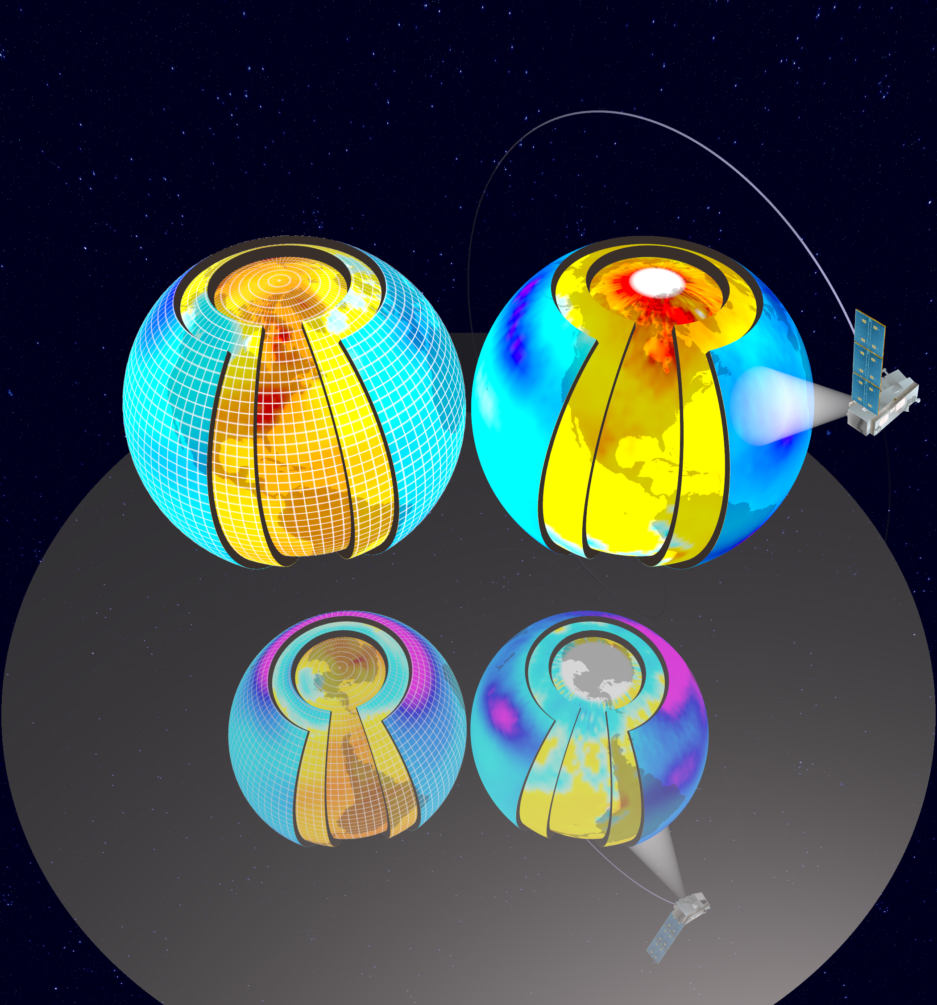

* Peter Gleckler et al., Nature Climate Change | Letter, “*Human-induced Global Ocean Warming on Mutildecadal Timescales*”, animation on increases in upper-ocean temperatures. Several studies have used well-established detection and attribution methods to demonstrate that the observed basin-scale temperature changes are consistent with model responses to anthropogenic forcing and inconsistent with model-based estimates of natural variability, June 2011. [URL Link to Animation]



* Sean Williams et al., “*Visualization and Analysis of Eddies in a Global Ocean Simulation*”,The Okubo-Weiss parameter visualized at depth by removing all low-vorticity points. The three-dimensional shapes of the eddies are now made clear: in the region containing the Gulf Stream, several strong eddies reach very deeply into the ocean, while smaller eddies remain near the surface, and the Gulf Stream itself only dominates near the surface. May 2011. [http://viz.lanl.gov/publication/movies/Eddies.m4v, <http://viz.lanl.gov/publication/movies/Eddies-Globe.mp4>, <http://viz.lanl.gov/publication/movies/Eddies-Atlantic-Globe.mp4>, <http://viz.lanl.gov/publication/movies/Eddies-Orbit.mp4>]



# Appendix C Use Cases

The use-case diagram for UV-CDAT shown in Figure LLL includes an actor (climate scientist or policy-maker figure) and specific use cases (oval shapes). High-level UV-CDAT system functions and requirements can be seen in the use-case diagram. Actors are entities that interact with the system, while use cases are the system functions the actors involve in their research. The use-case diagram tells “WHAT” the system should do, but does not illustrate “HOW TO” complete the action. The “HOW TO” will be outlined in the architecture section of this document.



**Figure LLL:** Use Case Diagram for UV-CDAT

## Use-case 1: High spatial resolution, parallel, image sequence production

**Actor:** Climate/Data Scientist

**Use Scenario** The user chooses to produce an image sequence by producing one picture per time step.

* More than one processor is used to iterate through N number of 3-D spatial fields saved at time steps, 0,1…,N-1, run a filter on each, and render N sequential 3D images.
* The data should be high resolution, i.e., 1/10-degree global ocean (3600x2400x42).
* The data should be structured, i.e., rectilinear grid.
* The data for each time step should be divided spatially and distributed across more than one processor.
* The data should have a filter, run in parallel, which produces geometry, which is then rendered and composited to produce a single image.

**Alternative Paths:**

**Exceptional Cases:**

**Frequency:** High

**Criticality:** High

**Risk:** High

## Use-case 2: High spatial resolution, parallel, time average

**Actor:** Climate/Data Scientist

**Use Scenario:** A user requests a data set be averaged across a number of time steps.

* More than one processor is used to iterate through N number of 3-D spatial , run a filter on each, and render a single 3D image.
* The data should be high resolution, i.e., 1/10-degree global ocean (3600x2400x42).
* The data should be structured, i.e., rectilinear grid.
* The data for each time step should be divided spatially and distributed across more than one processor.
* The operation should return a single time step average of the same spatial resolution as the time series that contains the positional temporal average.
  + For example 3 time steps = {1,2,3}, {1,2,6}, {7,8,9}
  + Return value is {3, 4, 6}

**Alternative Paths:**

**Exceptional Cases:**

**Frequency:** Medium

**Criticality:** High

**Risk:** High

## Use Case 3: Compute ensemble mean

**Actor:** Climate/Data Scientist

**Background:** Usually for each experiment, the modeling groups will produce multiple instances (or realizations) of the same experiment to obtain an ensemble that encompasses a range of chaotic behavior of the system. Statistics computed from the ensemble, such as the average and moments, are often used to understand natural system variability and the system response to changes in forcing. Typically for AR4 there were at most 10 such realizations per experiment, there will likely be more in the future.

**Use Scenario:**

* Step 1: identify all runs for the ensemble and the files for each run.
  + An example AR4 ncar-ccsm3 model in the box below. The one CDAT would actually use is highlighted; these xml files are recognized by CDAT and have aggregation of all the .nc files. So in this case we would need to open these 9 files.
* Step 2: identify common time between each runs
  + In this case all instances cover the same 1870 thru 1999 period. But we cannot assume this. In the case they do not cover the same periods, a decision needs to be made: Compute over the common period only, or compute over the "union" of times and weight each time according to the number of models.
* Step 3: average ensemble members over common time
  + In this case basically for each time step add all 9 instances together WARNING: We HAVE TO be careful about missing values, for 3D fields some "bellow ground" values might be masked. These will be different for each time step and each model. That means we cannot assume 9 at the end will divide the sum! (Note: It may be true across models, that vertical grids are the same for given models in a scenario. However, if they are not, then we will need to interpolate to a consistent vertical grid.)
* Step 4: dump out result: array or to file (in case memory is not big enough)

**Difficulties:**

* Identify files to use
* Identify which time period each instance covers and decide what to do if not common across members
* Pay attention to missing values
* **Alternative Paths:**
* Compute percentiles (median or 10 percentile for example) instead of mean.
* **Exceptional Cases**
* If the xml are not present then "generate them" (makes more sense) or "do without them"

**Frequency:** Medium

**Criticality:** Medium

**Risk:** Medium

20c3m/atm/mo/ta/ncar_ccsm3_0/run1/ta_A1.20C3M_1.CCSM.atmm.1870-01_cat_1879-12.nc 20c3m/atm/mo/ta/ncar_ccsm3_0/run1/ta_A1.20C3M_1.CCSM.atmm.1880-01_cat_1889-12.nc 20c3m/atm/mo/ta/ncar_ccsm3_0/run1/ta_A1.20C3M_1.CCSM.atmm.1890-01_cat_1899-12.nc 20c3m/atm/mo/ta/ncar_ccsm3_0/run1/ta_A1.20C3M_1.CCSM.atmm.1900-01_cat_1909-12.nc 20c3m/atm/mo/ta/ncar_ccsm3_0/run1/ta_A1.20C3M_1.CCSM.atmm.1910-01_cat_1919-12.nc 20c3m/atm/mo/ta/ncar_ccsm3_0/run1/ta_A1.20C3M_1.CCSM.atmm.1920-01_cat_1929-12.nc 20c3m/atm/mo/ta/ncar_ccsm3_0/run1/ta_A1.20C3M_1.CCSM.atmm.1930-01_cat_1939-12.nc 20c3m/atm/mo/ta/ncar_ccsm3_0/run1/ta_A1.20C3M_1.CCSM.atmm.1940-01_cat_1949-12.nc 20c3m/atm/mo/ta/ncar_ccsm3_0/run1/ta_A1.20C3M_1.CCSM.atmm.1950-01_cat_1959-12.nc 20c3m/atm/mo/ta/ncar_ccsm3_0/run1/ta_A1.20C3M_1.CCSM.atmm.1960-01_cat_1969-12.nc 20c3m/atm/mo/ta/ncar_ccsm3_0/run1/ta_A1.20C3M_1.CCSM.atmm.1970-01_cat_1979-12.nc 20c3m/atm/mo/ta/ncar_ccsm3_0/run1/ta_A1.20C3M_1.CCSM.atmm.1980-01_cat_1989-12.nc 20c3m/atm/mo/ta/ncar_ccsm3_0/run1/ta_A1.20C3M_1.CCSM.atmm.1990-01_cat_1999-12.nc 20c3m/atm/mo/ta/ncar_ccsm3_0/run1/ta_ncar_ccsm3_0.xml 20c3m/atm/mo/ta/ncar_ccsm3_0/run2/ta_A1.20C3M_2.CCSM.atmm.1870-01_cat_1949-12.nc 20c3m/atm/mo/ta/ncar_ccsm3_0/run2/ta_A1.20C3M_2.CCSM.atmm.1950-01_cat_1999-12.nc 20c3m/atm/mo/ta/ncar_ccsm3_0/run2/ta_ncar_ccsm3_0.xml 20c3m/atm/mo/ta/ncar_ccsm3_0/run3/ta_A1.20C3M_3.CCSM.atmm.1870-01_cat_1889-12.nc 20c3m/atm/mo/ta/ncar_ccsm3_0/run3/ta_A1.20C3M_3.CCSM.atmm.1890-01_cat_1899-12.nc 20c3m/atm/mo/ta/ncar_ccsm3_0/run3/ta_A1.20C3M_3.CCSM.atmm.1900-01_cat_1909-12.nc 20c3m/atm/mo/ta/ncar_ccsm3_0/run3/ta_A1.20C3M_3.CCSM.atmm.1910-01_cat_1919-12.nc 20c3m/atm/mo/ta/ncar_ccsm3_0/run3/ta_A1.20C3M_3.CCSM.atmm.1920-01_cat_1929-12.nc 20c3m/atm/mo/ta/ncar_ccsm3_0/run3/ta_A1.20C3M_3.CCSM.atmm.1930-01_cat_1939-12.nc 20c3m/atm/mo/ta/ncar_ccsm3_0/run3/ta_A1.20C3M_3.CCSM.atmm.1940-01_cat_1949-12.nc 20c3m/atm/mo/ta/ncar_ccsm3_0/run3/ta_A1.20C3M_3.CCSM.atmm.1950-01_cat_1959-12.nc 20c3m/atm/mo/ta/ncar_ccsm3_0/run3/ta_A1.20C3M_3.CCSM.atmm.1960-01_cat_1969-12.nc 20c3m/atm/mo/ta/ncar_ccsm3_0/run3/ta_A1.20C3M_3.CCSM.atmm.1970-01_cat_1979-12.nc 20c3m/atm/mo/ta/ncar_ccsm3_0/run3/ta_A1.20C3M_3.CCSM.atmm.1980-01_cat_1989-12.nc 20c3m/atm/mo/ta/ncar_ccsm3_0/run3/ta_A1.20C3M_3.CCSM.atmm.1990-01_cat_1999-12.nc 20c3m/atm/mo/ta/ncar_ccsm3_0/run3/ta_ncar_ccsm3_0.xml 20c3m/atm/mo/ta/ncar_ccsm3_0/run4/ta_A1.20C3M_4.CCSM.atmm.1870-01_cat_1949-12.nc 20c3m/atm/mo/ta/ncar_ccsm3_0/run4/ta_A1.20C3M_4.CCSM.atmm.1950-01_cat_1999-12.nc 20c3m/atm/mo/ta/ncar_ccsm3_0/run4/ta_ncar_ccsm3_0.xml 20c3m/atm/mo/ta/ncar_ccsm3_0/run5/ta_A1.20C3M_5.CCSM.atmm.1870-01_cat_1879-12.nc 20c3m/atm/mo/ta/ncar_ccsm3_0/run5/ta_A1.20C3M_5.CCSM.atmm.1880-01_cat_1889-12.nc 20c3m/atm/mo/ta/ncar_ccsm3_0/run5/ta_A1.20C3M_5.CCSM.atmm.1890-01_cat_1899-12.nc 20c3m/atm/mo/ta/ncar_ccsm3_0/run5/ta_A1.20C3M_5.CCSM.atmm.1900-01_cat_1909-12.nc 20c3m/atm/mo/ta/ncar_ccsm3_0/run5/ta_A1.20C3M_5.CCSM.atmm.1910-01_cat_1919-12.nc 20c3m/atm/mo/ta/ncar_ccsm3_0/run5/ta_A1.20C3M_5.CCSM.atmm.1920-01_cat_1929-12.nc 20c3m/atm/mo/ta/ncar_ccsm3_0/run5/ta_A1.20C3M_5.CCSM.atmm.1930-01_cat_1939-12.nc 20c3m/atm/mo/ta/ncar_ccsm3_0/run5/ta_A1.20C3M_5.CCSM.atmm.1940-01_cat_1949-12.nc 20c3m/atm/mo/ta/ncar_ccsm3_0/run5/ta_A1.20C3M_5.CCSM.atmm.1950-01_cat_1959-12.nc 20c3m/atm/mo/ta/ncar_ccsm3_0/run5/ta_A1.20C3M_5.CCSM.atmm.1960-01_cat_1969-12.nc 20c3m/atm/mo/ta/ncar_ccsm3_0/run5/ta_A1.20C3M_5.CCSM.atmm.1970-01_cat_1979-12.nc 20c3m/atm/mo/ta/ncar_ccsm3_0/run5/ta_A1.20C3M_5.CCSM.atmm.1980-01_cat_1989-12.nc 20c3m/atm/mo/ta/ncar_ccsm3_0/run5/ta_A1.20C3M_5.CCSM.atmm.1990-01_cat_1999-12.nc 20c3m/atm/mo/ta/ncar_ccsm3_0/run5/ta_ncar_ccsm3_0.xml 20c3m/atm/mo/ta/ncar_ccsm3_0/run6/ta_A1.20C3M_6.CCSM.atmm.1870-01_cat_1949-12.nc 20c3m/atm/mo/ta/ncar_ccsm3_0/run6/ta_A1.20C3M_6.CCSM.atmm.1950-01_cat_1999-12.nc 20c3m/atm/mo/ta/ncar_ccsm3_0/run6/ta_ncar_ccsm3_0.xml 20c3m/atm/mo/ta/ncar_ccsm3_0/run7/ta_A1.20C3M_7.CCSM.atmm.1870-01_cat_1949-12.nc 20c3m/atm/mo/ta/ncar_ccsm3_0/run7/ta_A1.20C3M_7.CCSM.atmm.1950-01_cat_1999-12.nc 20c3m/atm/mo/ta/ncar_ccsm3_0/run7/ta_ncar_ccsm3_0.xml 20c3m/atm/mo/ta/ncar_ccsm3_0/run9/ta_A1.20C3M_9.CCSM.atmm.1870-01_cat_1949-12.nc 20c3m/atm/mo/ta/ncar_ccsm3_0/run9/ta_A1.20C3M_9.CCSM.atmm.1950-01_cat_1999-12.nc 20c3m/atm/mo/ta/ncar_ccsm3_0/run9/ta_ncar_ccsm3_0.xml

## Use case 4: Compute average multi-model ensemble mean

**Actor:** Climate/Data Scientist

**Background:** This is basically the same problem as case 3, but each instance is on a different grid. We average over all instances, each of which is the output of a different model, to compute the “mean model” result, which as been shown to be superior to all models when compared to observations.

**Use Scenario:** User has coinciding time steps from a variety of models, run with the same starting conditions. For each time step, an average of the ensemble of data sets should be calculated, which requires regridding and/or registration of the data sets.

* Step 1: identify all models for this ensemble
* Step 2: identify common time between each runs
* Step 3: identify a target grid to which all model will be regridded
* Step 4: average ensemble members over common time and on common grid
* Step 5: dump out result

**Difficulties:**

* Identify files to use.
* Identify which time period each member covers and decide what to do if not common across members.
* Pay attention to missing values.
* Decide on a regridding method and a target grid that make sense.

**Alternative Paths:**

* Calculate the median (usually preferred to the mean model) (eliminates outliers).
* Calculate the standard deviation or other statistics

**Exceptional Cases:**

* If the XML are not present then "generate them" (makes more sense) or "do w/o them".

**Frequency:** Medium

**Criticality:** Medium

**Risk:** Medium

## Use case 5: Compute departures from climatological boreal winter

**Actor:** Climate/Data Scientist

**Background:** Scientists frequently focus on departures (or anomalies) from seasonal or monthly climatology. The first step is to produce a model’s climatology of monthly and seasonal averages through an annual cycle.

**Use Scenario:**

* Step 1: identify file(s) covering the time period for the climatology.
* Step 2: compute climatology over period of reference (climatology is defined usually as a 30 years average)
  + Average the December (D), January (J), and February (F) files over the period of reference
  + Note that boreal winter spans calendar years. For example the first DJF only has 2 months, the last one only has 1 month. Rules need to be put in place to decide how to weight these cases! WARNIG 2: Time bounds MATTER, for data set expressed in "months since" Jan and February have the same length (1 month), but for data set expressed in "days since" Jan has a length of 31 whereas Feb has a length of 28 (and even 29 every 4th years) once each DJF has been computed, average them all together, that is our climatological DJF
* Step 3: identify file(s) covering departures to be computed
  + Can be longer than ref period
* Step 4: compute seasonal means
  + Repeat the first part of the process for computing the climatology, obtaining the "Seasons"
* Step 5: remove climatology from step 4
* Step 6: dump out result

**Difficulties:**

* Time bounds matter!
* Missing values!

**Alternative Paths:**

* Annual cycle or other seasonal period, instead of DJF

**Exceptional Cases:**

**Frequency:** Medium

**Criticality:** Medium

**Risk:** Medium

## Use case 6: Convert from hybrid to standard pressure levels

**Actor:** Climate/Data Scientist

**Background:** The stand vertical dimension of 3D spatial meteorological data is hydrostatic pressure with units of hPa. Many atmospheric models use a different vertical coordinate and their output is not stored on pressure levels (there are 17 standard pressure level in AR4). Consequently, model results are usually interpolated back to standard pressure levels. As an example, the conversion from hybrid to standard pressure levels is presented.

**Difficulties:**

* The horizontal variation of hydrostatic pressure is not orthogonal to the surface, resulting in constant pressure surfaces that intersect the lower boundary.

**Alternative Paths:**

* Different vertical coordinate systems

**Exceptional Cases:**

* Step 1: Identify file(s) covering period to convert
* Step 2: compute "pressure" field over time covered
  + Conversion requires the hybrid coefficient vectors A and B, from the model and the global surface pressure field (2d lat/lon): compute P = B*Ps + A*P0
* Step 3: For each output level to a linear/log interpolation from pressure field to actual output pressure (mask out below ground)
* Step 4: Dump out result

**Frequency:** Medium

**Criticality:** Medium

**Risk:** Medium

## Use case 7: Compute a time series of a regional average

**Actor:** Climate/Data Scientist

**Details:** Read in data over a spatial region and return an average value at a given time. This is typically a drop in dimensionality

**Use Scenario:**

* Step 1: Identify needed file(s) to cover time period
* Step 2: Identify non-time dimensions
* Step 3: Average over non-time dimensions for each time value in the series, Note: order of calculation may be important because of treatment of missing values
* Step 4: Create time-series file of areal averages

**Difficulties:**

* Handling of missing values and area weights for grid points in averaging areas

**Alternative Path:**

* Single location, difference between 2 locations (North Atlantic Oscillation, etc.)

**Exceptional Cases:**

**Frequency:** Medium

**Criticality:** Medium

**Risk:** Medium

## Use case 8: Computing a zonal mean

**Actor:** Climate/Data Scientist

**Background:** many fields have a strong latitudinal dependence, which can be easier to discern once they have been zonally averaged.

**Use Scenario:**

* Step 1: identify file(s) to cover time period
* Step 2: identify "zonal" dimension (longitude) and bounds for each zonal band
* Step 3: average over "zonal" dim
* Step 4: dump out result

**Difficulties:**

* Non latitude/longitude grids will require either interpolation or alternative averaging

**Possible variation:**

* Use level instead of longitude average

**Frequency:** Medium

**Criticality:** Medium

**Risk:** Medium

## Use Case 9: Batch Processing

**Actor:** Climate/Data Scientist

**Use Scenario:** A program is written that uses the UV-CDAT framework to produce a product. This program is submitted to a job scheduler on a supercomputer and writes it’s product to a file system.

**Alternative Paths:**

**Exceptional Cases:**

**Frequency:** High

**Criticality:** High

**Risk:** High

## Use Case 10: Interactive Processing

**Actor:** Climate/Data Scientist

**Use Scenario:** A Graphical User Interface that uses the UV-CDAT framework to load and transform data sets is used to interactively explore one or more data sets using distributed memory back-end processing.

**Alternative Paths:** GUI runs in serial.

**Exceptional Cases:**

**Frequency:** High

**Criticality:** High

**Risk:** High

## Use Case 11: Time Dependent Processing

**Actor:** Climate/Data Scientist

**Use Scenario:** A processing step is called that requires an entire time series to be processed in order to produce a result.

**Alternative Paths:**

**Exceptional Cases:**

**Frequency:** High

**Criticality:** High

**Risk:** High

## Use Case 12: Time Independent Processing

**Actor:** Climate/Data Scientist

**Use Scenario:** A processing step is called that only requires a single time step to be read to produce a result.

**Alternative Paths:**

**Exceptional Cases:**

**Frequency:** High

**Criticality:** High

**Risk:** High